??Gupta
300 AD – roughly 600 AD tk gupta age we are having gupta gae

Golden age of gupta bhe bolte hai ancient india ko

Prakrat is the language of ordinary masses basically women and sudras

1

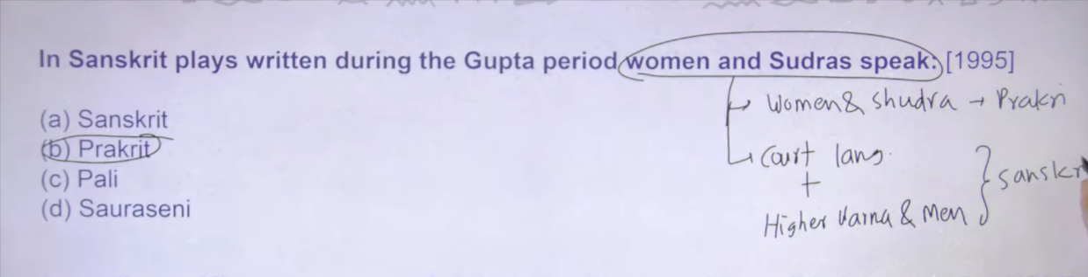

Gupta ke court lagangue and men of higher varna ke lagaue the Sanskrit
India me different different type ke languages chalte hai johaigher classes hai wo English me baaat krta hai non higher claas johai wo kise regional language me baat krta hai
Generally but iska matlab ye nahi ke higher class ke logo ko regional laguange nai ate aur genral people ko English nahi ate
It is about speaking style that is there varied india me jo mitla hai wo tabe bhe varied raha hoga
Gupta time ke jo sanskrti litreatue hai unse ye j ankari milte hai ki common women and sudra wo prakrit me baat krte hai and higher class and court people sanskirt me baat krte hai
This is the peculiarity jo gupta time ke drama and play writers hai unke hai

2
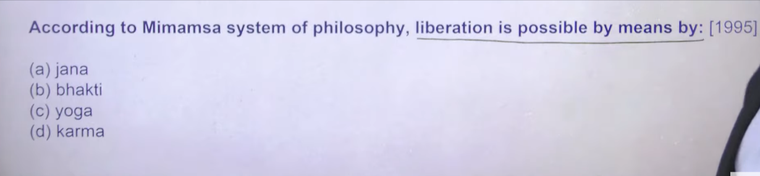
Ans:b

To memansa ye jo six school of Indian philosophy hai
Samkhya, vaseshka, , yoga, memansa, uttarmemansa

To jo Indian school of philosophy hai uske uppar I am going to take seprate lecture because now we don’t have much time to get into in detail
“Liberation is possible by means of” ka Hindi matlab hota hai:
👉 “मुक्ति (मोक्ष) संभव है … के माध्यम से”

🔍 Breakdown samajh lo:
- Liberation = मुक्ति / मोक्ष
- is possible = संभव है
- by means of = के माध्यम से / के द्वारा

📌 Example:
Liberation is possible by means of knowledge
👉 ज्ञान के माध्यम से मुक्ति संभव है

📖 1 line yaad rakhne ke liye:
👉 “by means of” = “के माध्यम से”

Agar chaho to main is type ke aur philosophy / English phrases ke meanings bhi simple tarike se samjha deta hoon 👍

3
Ye sare ke sare cheeze gupta age me ku hai kuki majority of sanskirt literature jo hai wo gupta time per compile hua hai gutpta time onward ye sare cheezo ke information mile hai
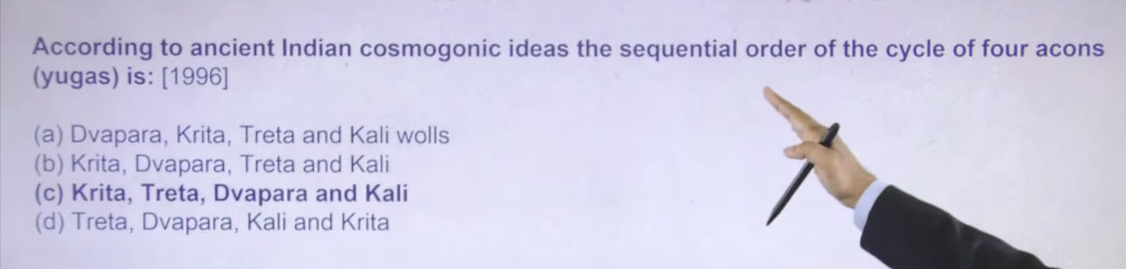
Ans:C

4
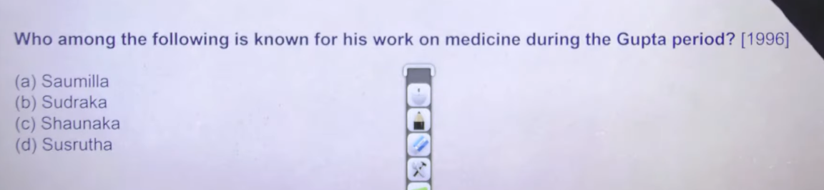
Ans: D
Shsrutha ke susrutha Samhita is consider as one of ealiest work on surgery
Shrushurta ko father of Indian surgery bhe botel hai
So he has given name of 100+ different instrument thereafter usne different different disease ke baare me batya hai and he has given the procedure that exact surgery kaise karne hia
One of the compex procedure that he has to carry out is caterak surgery
So caterak surgery ka procedure bhe inhone batya hai so obviously ab eke jaise sophisticated surgery nahi hua krte the us time per kafi painfull surgery hote the because in logo ko anesthisia nahi pta tha
But they could treat those disease even if the proceeds was lethal one itself
To shurusuta ka shrushuta Samhita belong to gupta age

5
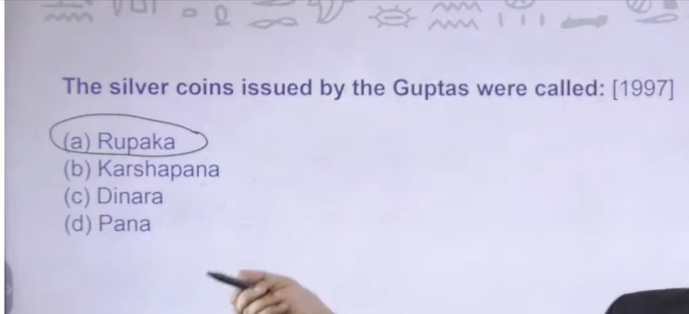

Gold coin of gupta is called as dinnara
Karshapana and pana in coins ka reference humko mahajanpaada period ke onwards se milna chalu hua hai
6th centaury bce ke onward humko inka reference milta hai hai kuch to pana aur karshpana jaise cheeze hua krte the

Sabse pahle jo coin ka reference humko mila hai wo vedic literature me milta hai uska naam hai niksha niksha sirf naam ka hai vedic logo ne literature me likh kar Rakha hai but hum lgoo ko iska koi archalegical evidence nahi mila hai
Thereafter
6th and 5th cenatruy bce ke time per hum lgoo ko punch mark silver coin ka evidence milt ahia archaeological evidence me mila hai isley uska sabse pahle coin mante
Earliest evidence of coin mante hia kuki iske archalegoical praman milte hai
Thereafter 6th to 4th cenatry me karshpana and paan ke literature evidence ile hai
Uske baad ata hai Mauryan age me bhe punch mark silver coin he chalte the

Uske baad
Post Mauryan age me sabse pahle gold coin issue karne wala indo Greek dynasty the
Indo Greek dynasty was the first dynasty whom issue first gold coin
Aur indo Greek dynasty he pahle dynasty the jisne human ka face coin per lagana chalu kyia tha tb se aaj thke world me wjo bhe courrynce hai us per ek face hona jarrure hota hai
Uske baad invaders ne gold coin silver coin bronze coin etc chalu karna start kr dyia tha aur ye same practice through out ancient india continue rahe
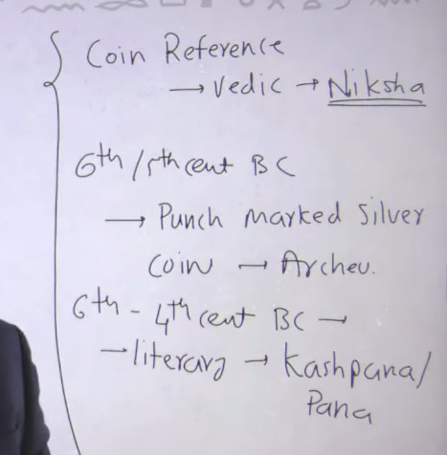
This is the certain information about coinage hisotyr hai

6
Vishakhadutta ka book hai mudraraksha and devichandrguptam these are two impo book of vishakdutta
Mudraraksha has story that how chankya defeated Raksha Raksha is used to be the prime ministyr of dhananda
And thereafter mudraraksha ne hum lgoo ko batya ke there has no war fare between Mauryan and nanda
Chankya defeated nand through treachery cheating kerke throne se nikala chankya ne fir Chandragupta Maurya ko king banya ye sare story milege mudraraksha me
Visahwkadutta ka ek aur book hai devichandragutpam jisme usne chandragutpa second ke bareme mention kyia hai visshakadutta gutpa dynasty ke time per tha but isne Mauryan dynasyt ke bare me likh kr Rakha tha
Isne chandragutpa second ke bare me likha tha ke he defeated his own brother and killed ramgutpa bada bahai and marry his wife tdhruvdevi also
Kuki raamgutpa shakas se war me haar gyaa tha aur he was ready to give his wife to shakas ruler isley usne apne bhai ko maar dyia one of the internal battle field me hara tha
Then first chandragutpa second ne pahle sakas ko haryayand then defeate his brother and killed and then marry dhruvdevi
Ye story hume devichangupta me milte hai

Both are sanskrti drama aor story hai isley isko drama bolte hia

Varahamihra ye ancient time ka famous astrologer hai
Gutpa time per he was the person who suggest that men of different varna shall have the houses of different sizes ki jinta chota apka varna hai utna chota apko ghar chaye aur jitna bada apka varna hai utna bada apko varna chaye
At the gupta time he was man who suggest first time that different men varna has different category housle like if the m ki jitna chota apka varna hai utna chota apko ghar chaye and jitna bada aapka varna hai utna bada apko ghar chaye the man of different varna shall have different size of houses
So varhamihra is related to astronomy joteeshashtra se related the

Chrak shrushura ke jaise he tha but shurshurta is considered as fater of surgery
Charak is considred as the one fo the eariliest greatest mediciologist inko medicine ka acha knowledge tha
To kaun se disease me kaun sa medicine lena chaye iske information hum lgoo ko charak Samhita me mile hai

Brahmgupta ka book hai brahmasfutika sidhanta
He has given us the technique to commit the area of cycle quadrilateral and theref after Brahmagupta is also credited to giving us the number to 10 ke uppar ka
0-9 tk ke number hum logo ko aryabhatt ne dyia hai
That’s why hum numerology ka discouvering aryabhtaa ko dete hai
Fir 10 ke uppar ka number kaisa hona chaye ye hum lgoo ko brahmasfutika sidhanta ne byata hai brahmgutpa ne batya hai

That’s why hum zero ka invention aur numerology ka invention hum aryabhatta ko dete hai 10 ke uppar ke number kaise hone chaye ye hum lgoog ko brahmgupa ne batya hai

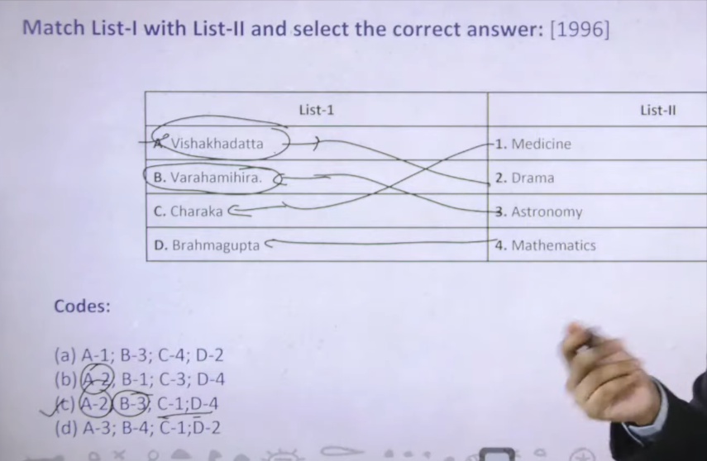

7
Mrachhakatika it is the love story of rich girl and poor man
Mrachaktakam is little clay cart sanskrti word ka translation in englihs
To ismee ye story hai ki society me rich girl hai to how differenclut to her to marry a poor boy ye story mrachakatika me mile hai

Bilhana 12th cenatry me he was the court poet of chalkyua king vikramdeva Vikram deva charti naam ka biography likha tha unhone apne king k lyie
Varahamihra jinhone likha tha birhat Samhita brahmasfutik sidhant alag ahi aur birhat Samhita alga hia
Birahat Samhita means jo bhe earth ke uppar cheze hai uska saar
To astrology se related jo bhe different different cheeze hai jo hume varahmihra ne de hai wo ayege vrahat Samhita se

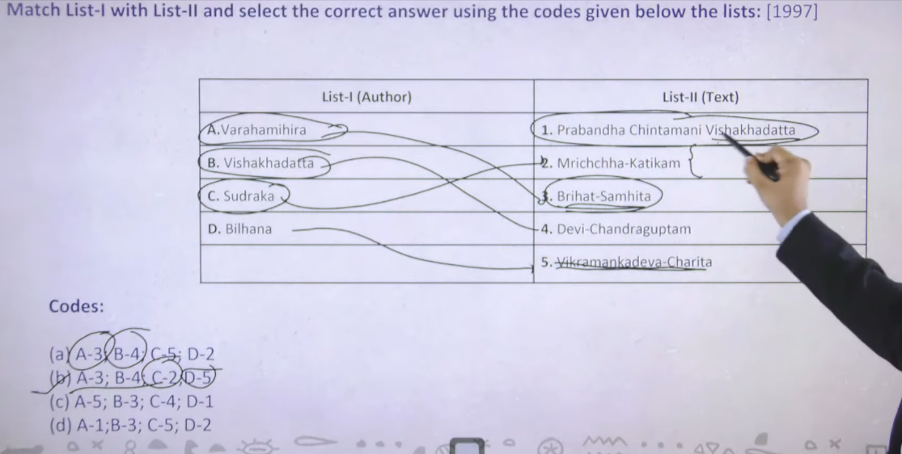

8
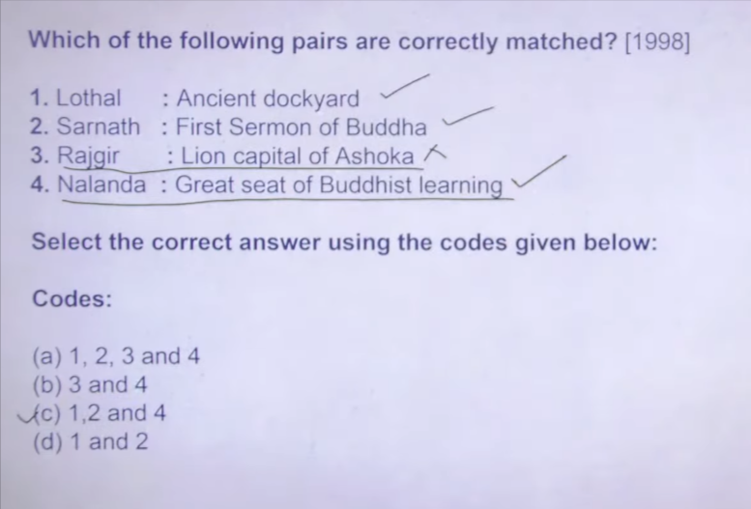

Sarnath me dharma chakra parevartan mudra hai matlab kya hai turning of wheel of law hai because that is the place where the first sermon of buddha was taken

Lion capital of Ashoka hai wo hum logo ne sanchi se lyia hai
We have got it from sanchi

9
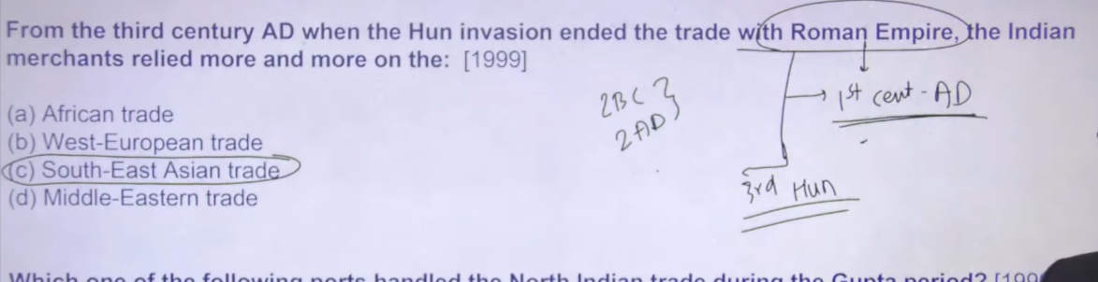
👉 तीसरी शताब्दी ईस्वी के बाद, जब हूणों के आक्रमण ने रोमन साम्राज्य के साथ व्यापार को समाप्त कर दिया, तब भारतीय व्यापारी अधिक से अधिक … पर निर्भर होने लगे।

South asia wale jo area hai like java , Malaya, peninsula, waha se india ke trade badne lage the because trade with roman end hogae the trade with roman do Karno se end hue the 1 ce ad me roman ne india ke trade ko ban kr dyia tha because it was quiet simple roman gold lekar ate the hum log spices lekar jate the then gold and spiceds ko mix kargoge tho gadbad hoge to balance of trade is in favour of india there was huge rain of gold therw why ultimately roman ne india ke sath ka trade ko ban kr dyia tha on the otherhand ye 3 centrya ad ka hun invasion hai uske pahle second centary Bc se 2 nd centary Ad ke beech me humne char invasion to pahle he dekhe the to ye invasion ye signify karta hai ki overland jo trade route the jitne bhe central asia and eurpote ke trhought trade route jate the yaha per bahut ulath pulath mache hue the at that time pahel indogreek fir shakas, phalvas , kushanas ye sab central asia se aa rahe the matlab ye jo trade link hai kafi distrupt ho chuka tha to pahle ye invasion fir usek baad
    - ce ad me roman ne he trade ban kr lyia then

then third cneatry ad ke around hunas ka invasion chalu ho gayay to ye jo hunas invasion hai ye bhe kafi set back tha for the overland trade with europian empire precisely roman empire and that’s why ultimately ye trade decline hue

to ikse baad india ne south east aisa me trade ko focus karna chalu kyia

toward the end of ancient india me 8th se 10 ce ke bech me south india was undert the chola dynasty chola dynasty ne south east asia wale jokingdomhia java , peninusal Malayan , inko capture karna chalue kyia because trade route were imperotant at that time
10
Ans: A

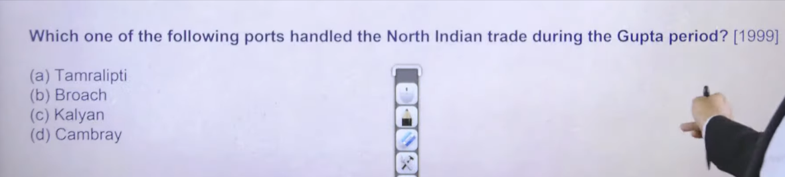
Remaing three port abhe ke Gujrat and maharast ke around hai kalyan chaul ye to trade port maharastra ke area me hai these port is used to carry out trade with south certain influence of guptas were there on these port also
Tamralipit north india ka port hai
It is remain the significant port through out ancient period of time
Takshila se nece Mathura, Mathura se patliputra fir patliputra se tamralipti ye wala jo trade route hai wo anient times uttarpath ke naam se jana jata tha uttarpath kht he hota tha tamrlipti me
Tamrlipiti modern day Bengal me hai
Thatw hy tamrilpiti will bhe the ultimate answer over here

11
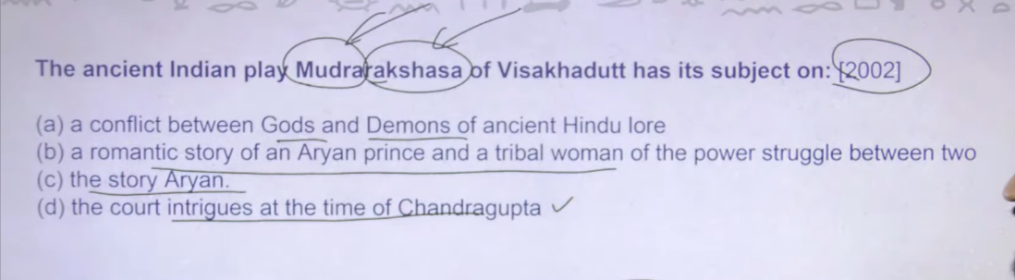

ANS: D
👉 विशाखदत्त का प्राचीन भारतीय नाटक ‘मुद्राराक्षस’ चन्द्रगुप्त के समय के दरबारी षड्यंत्रों पर आधारित है।
👉 विशाखदत्त का प्राचीन भारतीय नाटक ‘मुद्राराक्षस’ का विषय है।
(अगर पूरा वाक्य बनाना हो तो:)
👉 विशाखदत्त का प्राचीन भारतीय नाटक ‘मुद्राराक्षस’ का विषय दरबारी षड्यंत्र है।
- Ancient Indian play = प्राचीन भारतीय नाटक
- Court intrigues = दरबारी षड्यंत्र
- Time of Chandragupta = चन्द्रगुप्त का समय

Ki kaise chankya ne kaise Raksha who was the pm of dhanandna uska pahle kahtal akrya fir udhanand ko court se nikal pheka to ye wale jo story hai
This is the most apprpirate of mudraraksha of vishwkadutta
Name he suggest karta hai
Rakhsan ka mechanization means uskeo kaise play kyia chankya ne

12
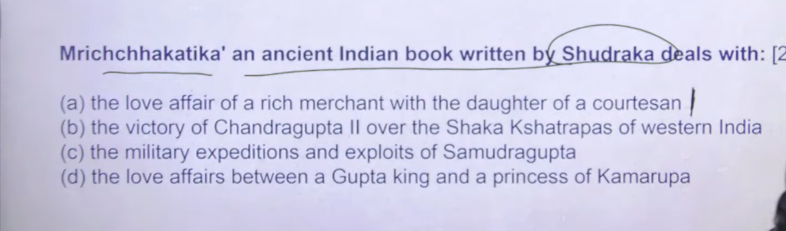
Ans: A

👉 एक धनी व्यापारी का एक वेश्या की पुत्री के साथ प्रेम संबंध।

🔍 Word meaning:
- Love affair = प्रेम संबंध
- Rich merchant = धनी व्यापारी
- Daughter of courtesan = वेश्या/नगरवधू की पुत्री

13
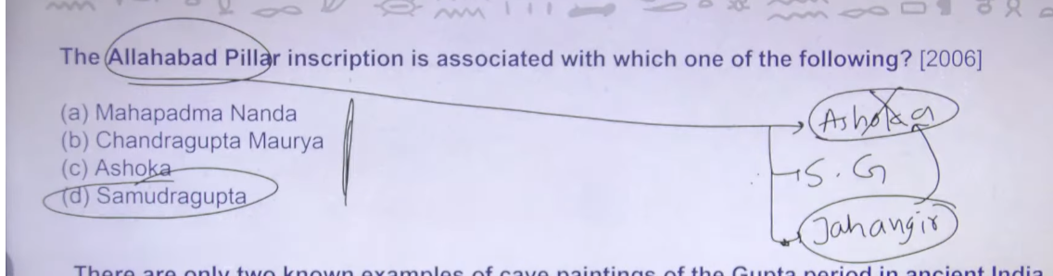

Ans: C
Because C and D both are answer
Because Allahabad pillar inscirtpion is Ashoka and if the mention is prayagprashti then it is samduragutpa
The Prayag Prashasti and the Allahabad Pillar Inscription refer to the same physical object, but describe different, stacked inscriptions. It is a 3rd-century BCE Ashokan pillar featuring 4th-century CE Gupta-era praises (Prashasti) of Samudragupta by Harisena in Sanskrit, plus earlier Ashokan edicts in Prakrit.

Key Differences and Owners:
- Prayag Prashasti (The Inscription): A poem/eulogy praising Emperor Samudragupta of the Gupta Dynasty (composed by his court poet Harisena).
- Allahabad Pillar Inscription (The Object): The overall monolithic pillar, containing inscriptions from Ashoka (Mauryan), Samudragupta (Gupta), and later Jahangir (Mughal).
Key Details:
- Location: Originally at Kaushambi, now located in the Allahabad fort.
- Purpose: The Prashasti details Samudragupta’s military campaigns, conquests, and policies of expansion.
- Languages: The pillar holds Brahmi script for Gupta/Ashokan parts and Persian for Jahangir's, showcasing the blending of three different historical eras

Your statement is largely correct. The Allahabad Pillar is a monument that contains inscriptions from multiple rulers, serving as a layer of historical records.
- Ashoka (3rd Century BCE): The pillar originally belongs to the Mauryan Emperor Ashoka. It holds his edicts in Prakrit language and Brahmi script, which emphasize his policies of peace and dhamma.
- Samudragupta (4th Century CE): The Prayaga Prashasti (or Allahabad Pillar Inscription) is indeed a eulogy of Samudragupta, the Gupta Emperor. It is written in Sanskrit, composed by his court poet Harisena, and inscribed on the same pillar to record his military conquests and achievements.
Key Facts regarding the Allahabad Pillar:
- Original Site: The pillar was originally located in Kaushambi and was likely moved to Allahabad by the Mughal Emperor Akbar.
- The Inscriptions: It holds three distinct sets of inscriptions:
  - Ashokan Edicts (3rd Century BCE).
  - Prayaga Prashasti of Samudragupta (4th Century CE).
  - Jahangir's Inscription (17th Century CE).
- Significance of Prashasti: The inscription highlights Samudragupta's victories over nine northern kings and twelve southern kings, often referred to as the "Napoleon of India" due to these conquests.

Ye jo allahaba pillar inscription hai iske uppar teen logo ki inscription milte hai Ashoka samdudragutpa , jahangirii
Jaghanitir ne jo apne inscription likhe wo directly Ashokan inscription ke uppar likhe the that’s why Ashoka ke inscription damage hog ae humko suko theek se nahi padd pate hai ki Ashoka ne uske uppar kya likha hai
Actualy me teen ke inscription availbel hai but technically pahne me samdurgutpa nad Jahangir ke aa rahe hai
Ashoka ka pillar hai jisme pupar ye teeno ke inscription hai ye ek jamane me pryayaga raaj me hua krta tha fir fir later on jahgangire ne usko allhahabd ke kile me lagakr rakh dyai hai
Now kuch kuch remain of Ashoka inscription visible hai

14
AnsL:A

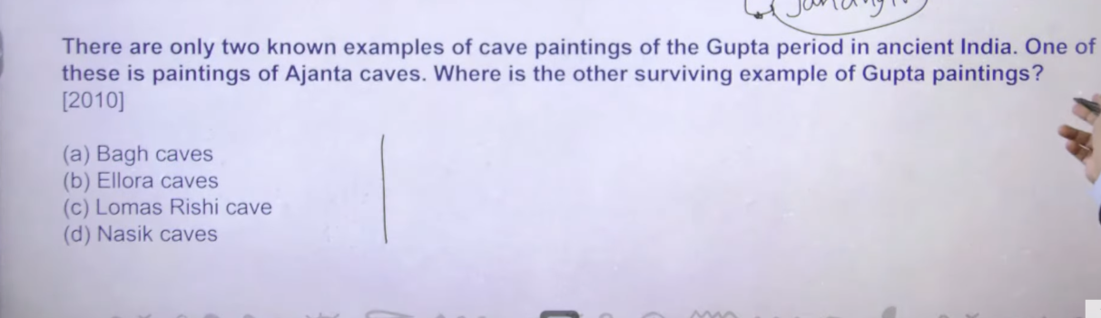
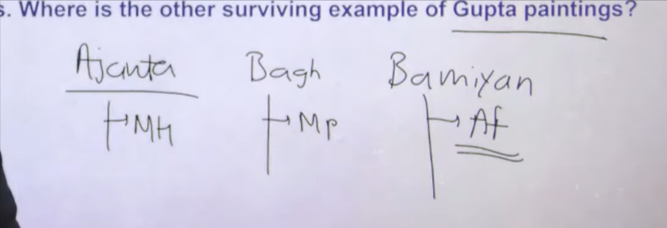
Ellora painting post gutpa period ke hai elloar is patroinisezese by rastrkuta
Nasik cave ko regional dynasty ne patronize kyia pahnele nahpana naam ka regional chatrap tha shakas dynasty ka usen patrozine kyia fir satvahana dynasty ne patronize kyia
Then bagh cave of mp

Ajanta, bagh, Bamiyan ye teen cave hai jo gupta ko attribute karte hai
Bamyian is in afganistan unfortuantly talibanne usko destroy kr dyia hai
Remaining tow me surving painting of gutpa period ke abhe bhe milenge
To yaha per most appropriate answer is bagh

15
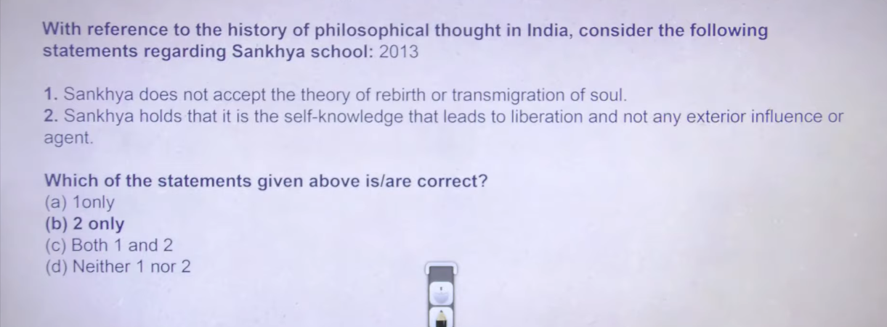

Ans: B
👉 सांख्य दर्शन के अनुसार मुक्ति आत्मज्ञान से प्राप्त होती है, न कि किसी बाहरी प्रभाव या साधन से।

🔍 Word meaning (quick):
- Sankhya = सांख्य दर्शन
- Self-knowledge = आत्मज्ञान
- Liberation = मुक्ति / मोक्ष
- Exterior influence/agent = बाहरी प्रभाव या साधन

📌 Easy line:
👉 सांख्य दर्शन: आत्मज्ञान → मुक्ति

👉 पुनर्जन्म और आत्मा के आवागमन का सिद्धांत

🔍 Word Meaning:
- Rebirth = पुनर्जन्म
- Theory = सिद्धांत
- Transmigration of soul = आत्मा का एक शरीर से दूसरे शरीर में जाना (आवागमन)

📖 “Transmigration” का मतलब:
👉 आत्मा का एक शरीर छोड़कर दूसरे शरीर में प्रवेश करना

📌 Easy line yaad rakhne ke liye:
👉 Transmigration = आत्मा का स्थान परिवर्तन (शरीर बदलना)

Six limb of Indian school of philosophy hai hindu philosophy hai
Hindu ya ko bhe religion ap dekho uska ultimate objective hota htia succession from the birth means soul ko moksh milna chaye rebirth nahi hona chay
  - agar appka dharma hai to apke paas transmigration wala panga hai buddhist and janism ne bhe ultimate transmigration of soul ko later on maan lyia tha initial me naih mante the
transmitragtion of sould means mere soul hai mere body marne ke baad perish hone ke baad soul kise aur body me chale jayege ab ye transmigration ku hota hia to ye jo mere desire hai ye mere nahi atma ke desire hai agar atma ke diestire ful fil nahi hue to atma going to take rebirth ab agar apko atma ke rebirth ko rokna hai to uske lyei apko moksh prapth karna padega uske lyei alagalg regliion me alag alg methoda hai like buddis jainis
and as per as concern hindu religion me six school of philisoypy hai to tak e moksh
isme Samkhya and vaisheshka ye do philosophy belief karte hai materilasim ke uppar inka bolan hai ke dharma warm chodo knowledge gain karo knowledge gain karne per apko pata chalega ke dunya moh mayaa hai phir apka automatic detachment ho jayega

yoga philosypy bolta hmosksh ke lyie meditaion prachitce karo maan ke uppar kabu karo jsse aapke desire khtm honeg aur earthly life ke uppar ka jo hold hai wo khtm hoga and you can easily attain the moksha

memansa and uttarmemans
memansa suggerst karta hai vedic practicese follow karo apko moksh mil jayega
uttarmemans – jiske uppar apkao aaj ka pura hindusm based hai wo hai Vedanta
uttarmeamns abatat hai bhkti marg manta ka hke bhakti karo bhagawna ke puja archana karo jisse pako moksha milega

fir uttarmemansa ya vedantik school of philosophy hai uske uppar further division hai jiase dwaeet hai vishtadwaeeta hai etc
iske baad haman hindusm ak ek video dekh lena jisme bhakti and materilias ka basic difference samjha me aa jaye

to pahla wala to difenityel wrong hai kuki hindusm base he ikse uppar hai transmigration of soul hota hai jiske suna hia ke saat Janam hote hai
to ye to hindu school of philosophy ka base hai iske against to koi jayega he nahi Samkhya bhe nahi sankhya bhe nahi jayega

  - is true jisme bola hia knowledge gain karo se apko eartly moh maya se lagav khtm ho jayega you can attain moksha

check vedangas videos ‘

ncient Indian Philosophy में Six Schools of Philosophy (षड्दर्शन) वे छह आस्तिक दर्शन हैं जो वेदों को प्रमाण मानते हैं। ये सभी ज्ञान, आत्मा, ब्रह्मांड और मोक्ष को समझाने की कोशिश करते हैं। नीचे इन्हें थोड़ा विस्तार से समझिए:

1. Nyaya (न्याय दर्शन)
संस्थापक: Akshapada Gautama
मुख्य विचार:
- न्याय दर्शन तर्कशास्त्र (Logic) और ज्ञान प्राप्ति के साधनों पर आधारित है।
- यह बताता है कि सही ज्ञान कैसे प्राप्त किया जाए।
चार प्रमाण (Sources of Knowledge):
- प्रत्यक्ष (Perception)
- अनुमान (Inference)
- उपमान (Comparison)
- शब्द (Testimony)
उद्देश्य:
सही ज्ञान के माध्यम से मोक्ष (मुक्ति) प्राप्त करना।

2. Vaisheshika (वैशेषिक दर्शन)
संस्थापक: Kanada
मुख्य विचार:
- यह दर्शन पदार्थ (matter) और परमाणु सिद्धांत पर आधारित है।
- इसके अनुसार संसार छोटे-छोटे परमाणुओं (atoms) से बना है।
छह पदार्थ (Categories):
- द्रव्य (Substance)
- गुण (Quality)
- कर्म (Action)
- सामान्य (Generality)
- विशेष (Particularity)
- समवाय (Inherence)
विशेषता:
यह दर्शन भारतीय प्राकृतिक विज्ञान और भौतिक जगत को समझाने की कोशिश करता है।

3. Samkhya (सांख्य दर्शन)
संस्थापक: Kapila
मुख्य विचार:
- संसार दो तत्वों से बना है:
  - पुरुष (आत्मा)
  - प्रकृति (Nature)
- प्रकृति से 24 तत्व उत्पन्न होते हैं जैसे बुद्धि, अहंकार, मन आदि।
उद्देश्य:
जब आत्मा और प्रकृति का अंतर समझ में आ जाता है, तब मोक्ष मिलता है।

4. Yoga (योग दर्शन)
प्रमुख आचार्य: Patanjali
मुख्य विचार:
- यह दर्शन मन और शरीर के नियंत्रण के माध्यम से मुक्ति का मार्ग बताता है।
- इसका आधार ग्रंथ है Yoga Sutras of Patanjali।
अष्टांग योग (Eight Steps):
- यम
- नियम
- आसन
- प्राणायाम
- प्रत्याहार
- धारणा
- ध्यान
- समाधि
उद्देश्य:
मन को नियंत्रित करके आध्यात्मिक मुक्ति प्राप्त करना।

5. Mimamsa (मीमांसा दर्शन)
संस्थापक: Jaimini
मुख्य विचार:
- यह दर्शन वेदों के कर्मकांड (rituals) और यज्ञ के महत्व पर जोर देता है।
- यह मानता है कि धार्मिक कर्मों से धर्म और सुख प्राप्त होता है।
विशेषता:
- वेदों को अनंत और सर्वोच्च ज्ञान मानता है।

6. Vedanta (वेदांत दर्शन)
संस्थापक: Badarayana
मुख्य विचार:
- वेदांत का आधार उपनिषद, भगवद्गीता और ब्रह्मसूत्र हैं।
- इसका मुख्य विचार है कि आत्मा (Atman) और ब्रह्म (Ultimate Reality) एक ही हैं।
उद्देश्य:
ब्रह्म का ज्ञान प्राप्त करके मोक्ष पाना।

✅ सरल याद रखने की ट्रिक:
N V S Y M V
Nyaya – Vaisheshika – Samkhya – Yoga – Mimamsa – Vedanta

अगर चाहें तो मैं इन 6 schools की comparison table + UPSC/SSC exam के लिए 10 important facts भी बता सकता हूँ, जिससे यह topic बहुत आसानी से याद हो जाएगा। 📚
moksh ke lyei dhram ka marg kis philopgy me ata hai
मोक्ष के लिए धर्म (कर्म/कर्तव्य) का मार्ग मुख्य रूप से Mimamsa दर्शन में बताया गया है।
Mimamsa में धर्म का मार्ग
- इसके प्रवर्तक: Jaimini
- यह दर्शन वेदों के कर्मकांड (rituals) और धर्म पालन पर जोर देता है।
- इसके अनुसार यज्ञ, अनुष्ठान और कर्तव्य (धर्म) करने से मनुष्य को पुण्य मिलता है और अंततः मोक्ष का मार्ग मिलता है।
मुख्य विचार
- धर्म = वेदों में बताए गए कर्मों का पालन
- मनुष्य को अपने कर्तव्य और धार्मिक कर्म करना चाहिए।
- इन कर्मों से आत्मिक उन्नति और मुक्ति की प्राप्ति होती है।
✅ Short exam point:
“मोक्ष के लिए धर्म या कर्म का मार्ग – Mimamsa दर्शन”
अगर चाहें तो मैं आपको कौन-सा दर्शन मोक्ष के लिए कौन-सा मार्ग बताता है (ज्ञान, कर्म, योग) यह भी आसान तरीके से समझा सकता हूँ। 📚
baki sab me
आपने पूछा बाकी दर्शन (Six Schools) में मोक्ष का मार्ग क्या है। नीचे हर दर्शन में मोक्ष प्राप्त करने का तरीका बताया गया है:

1. Nyaya
मार्ग: ज्ञान और तर्क का मार्ग
- प्रवर्तक: Akshapada Gautama
- न्याय दर्शन कहता है कि सही ज्ञान (True Knowledge) और तर्क (Logic) से अज्ञान दूर होता है।
- अज्ञान खत्म होने पर मोक्ष प्राप्त होता है।

2. Vaisheshika
मार्ग: पदार्थ और आत्मा के सही ज्ञान का मार्ग
- प्रवर्तक: Kanada
- यह मानता है कि संसार के तत्वों (पदार्थों) को सही तरह समझने से आत्मा का ज्ञान होता है और मोक्ष मिलता है।

3. Samkhya
मार्ग: ज्ञान का मार्ग
- प्रवर्तक: Kapila
- इसमें पुरुष (आत्मा) और प्रकृति का अंतर समझना जरूरी है।
- जब आत्मा को यह ज्ञान हो जाता है कि वह प्रकृति से अलग है, तब मोक्ष मिलता है।

4. Yoga
मार्ग: योग और ध्यान का मार्ग
- प्रमुख आचार्य: Patanjali
- अष्टांग योग (यम, नियम, आसन, प्राणायाम, ध्यान आदि) के अभ्यास से मन को नियंत्रित करके मोक्ष मिलता है।

5. Mimamsa
मार्ग: धर्म और कर्म का मार्ग
- प्रवर्तक: Jaimini
- वेदों में बताए गए यज्ञ और धार्मिक कर्म करने से मोक्ष का मार्ग मिलता है।

6. Vedanta
मार्ग: ब्रह्मज्ञान (ज्ञान का मार्ग)
- प्रवर्तक: Badarayana
- इसमें माना जाता है कि आत्मा और ब्रह्म एक हैं।
- जब यह ज्ञान प्राप्त हो जाता है, तब मोक्ष मिलता है।

✅ Exam Trick (बहुत पूछी जाती है):
दर्शन | मोक्ष का मार्ग
Nyaya | तर्क और ज्ञान
Vaisheshika | पदार्थ का ज्ञान
Samkhya | पुरुष-प्रकृति का ज्ञान
Yoga | ध्यान और योग
Mimamsa | धर्म और कर्म
Vedanta | ब्रह्मज्ञान

16
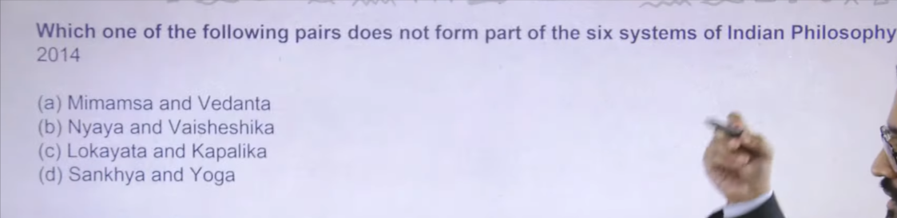

Ansc :C
Both are philosphyer

17
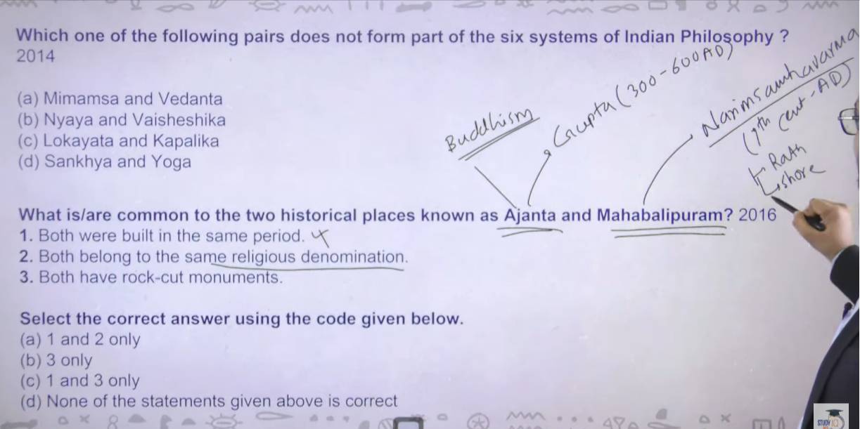

Ajanta is during guta time
And
Mahabalipuram usko narishmavarnaman ne 7th cenatruy AD me banya
    - - thery were butild in different age or time period
Ajanta me buddhist painting ahi padmapni ke paintg hai
Ellora me budhism janisme and hidusm ke instance milet eha
But ajanta me sirf buddhist ke
On the other hand narishmvarna – yaha per rath temple, shor temple desent ofgangez wala picture bhe milega
To ye sare hindusm se relate hai iraminant hai

Ans: b- 3 only
Both have rock cut mounument bade bde patharo cut kareke ye baney gae hai
Ajanta me 200+rock cut caves hai

18

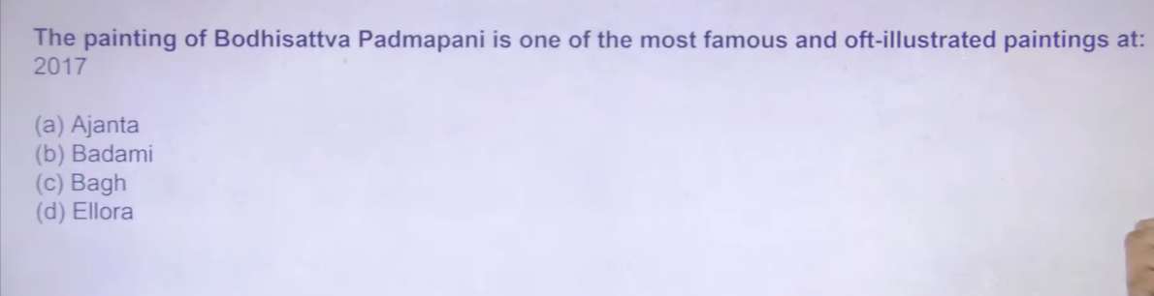
Ans: a

19
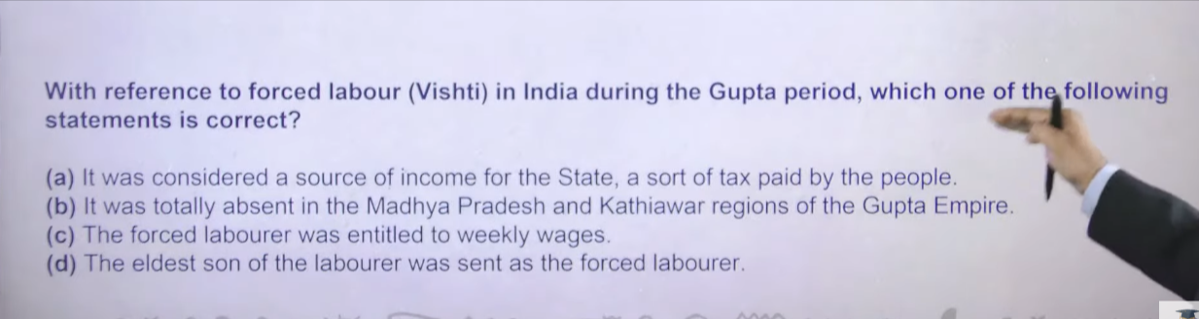

Ans:A

Vishti – force labout ye Mauryan time and gutpa dono period me tha iska character dono period me same he tha
For example agar mai trader hu mujhe state ko tax dena hai to I have money certain short of money to give the tax to state
Aur gag mai farmer hu tu mere paas kuch food produce hai jo mai tax ke rop me de skta hau
For example mai pottery making karta hu mai individual persion hu or pot banta hu ab mujhe state ko tax dena hai to mai state ko tax kais e dunga force laboutr ke through to mahne me ek ya do kdin ke lyie mujhe jaahna hai king ke paas aur king ke place per kaam karna hai free of cost
Isko bolte hai forced labout arnd ancient time me isko sanskrti me visti bolte the
To forced labour ya visti kyat ha state ko dyia hua tax tha
Like mai gutpa time per hu to mujhe aanta me jakar painting karne padege ye ho gaya mere tax dene ka one of the tareeka
So the answer overhere is A
Ans:A
2 madhaypradehs and kathyaivar gurjrat wale region se iske sabse Jayda instance dekhne ko milte hai because ye outskirt wale area the gupta time per aur aye artisian iten to amir nahi the ki city ke core me magadh wale area me Jakhar rahe to outskirt wale area se hum logo ko maxiume inscription mile hai jisse hum logo ko ye forced labour wale jisse forced labour ke bare me pta chal hai
    - forced labour me weelkly vages ka kaoi panga nahi hot ahia
    - father jo skill ed ho ta tha usko bulkar forced labour karwaya jata tha kuki son ko lekar wo kya karekga
    - wo skill was the tax that you are paying to the state
    - skill was important for forced labour or visthi

20
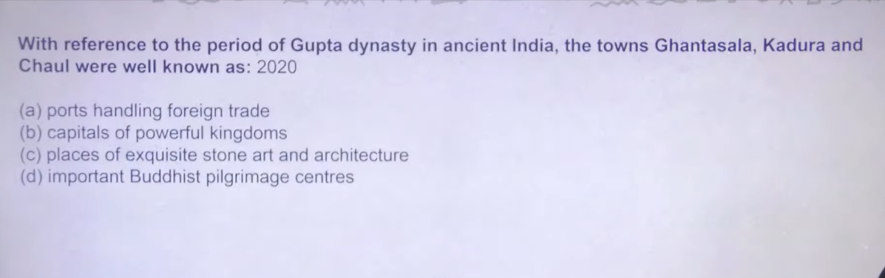

ANS:
Chaul and Kalyani was the two important port of the gupta time
Ghatasal and kadura maharast me gupta period of tiem ke p
mahrastra me
Ans A

Patronize means king ko artist ke kaam ke badle paise dega aur support
Karetga
Vimakadfiese and as well as kajula kadfesse dono ne gold coin issue kyie the apne time the same practise continue even the time of kanisk aor house of Kanishka

Linguistic history inida
Pali and prakrat
Dyrubg the time of mahjanpad hum logo ko do language mile hai ek to hai prakrat aur ek hai pali ye dono language of common means masses ke the janta ke ordinary lagnauge the ye hum logo ko kaise pata chal to buddhist text hai wo hum lgoo ko mile hai pali language me jains ke text mile hai prakrat lagnauge me Mauryan ke time per jo Ashokan inscription mile hai ye bhe prakrat lagnauge me likhe hai pali me likhe dono
Agar pm man ke bat hindi me krta hai to uska ek significance hai ke majorty of indina people know the lagnue of hindi
To us tiem per agar koi relgion and king ye lgangue use kar rahhai aur janta me kuch mesaage dena chata hai to means ye lagnauge of masses the to yeahe lagaue hai jo ordinary peole ko ate the baki inhe se aga eke lagnauge distrube hoan chalu hue
Pali se ayaya ardhamagadhi aur ardhmagdhi se magadhi kuch kuch isme prakrat ke bhe instance milege
Pali as well as prakrat dono he apko magadhi languge me milegne
Fir jo magadhi hai uske he latest version apko north india nad western idnia like maithali, bhojpurie etc me dekhne k o milenge
Western coast me maradhit, Gujrati, marwasdi inme se agar apko ek bhe lagnue ate ahi to baski sabasko samjhne me jaydya muskhil nahi hote kuki in sabhe ka ancient lineage hai wo apko prakrt and pali me dekhne ko milegna
To pali and prarkat ko consider kyia jata hia ki ye local lagnauge hai kuki by and large common people use krte the

Sanskrit jo hai Indian lagauge nahi h ye bahasr se aye hia Aryan ne jb invade kyia tb unke laguge sanskrt the obviousye theywere invaders to invader wali lagnue Indian accept krenege nahi karekeng to Aryan jb ayay to janta masses ke beech me sanskrti ka koi instance nahi mileta hai but elite section sanskrti patronize krta tha bhale he Ashoka ne inscription pali and prakrat me likhe but archya chankya ne arthsastra sanskrt me likha tha chankya has very verys superioty postion at that time in hierarcy means higher class ye lagn patronize krta tha

Fir 1 ce ad ke around ye time post gupta waal time hai at that tiem hum logo ko mila hai girnar rock edict shakar ruler rudradaman first
To ye grirnar rock edit first incsritpion hai jaha per major inscription Sanskrit me likhe hai ot by this time masses ko sanskrti ke bare me pta tha kuku agar major incsritpon sanskrti me likha jaa rhah hai but still the pali and prakrat certain remain the language of masses
]]== gupta period onward bhe common people ke languge pali and prakrat the
Sanskrit sjo bahar se aee hue lagnauge the jisko indo Aryan bhe bola jata hai indo Aryan ek jo offshoot hai wo sanskrt hai aur ek jo offshoot hai wo English hai to ajj bhe app dekho sanskrti and English in dono me kuch word common milenge kuk in dono ka ultimate route dekhoge to wo hai indo Aryan bhar se aee hue lagngue hia
Pali and prakrat indegenoius lague janta ke lagauen hai through ut ancient india rahe hai

Aur wiase he isko ajj ke time per compare kyai tha to higher administrative level per jo lgo h unme English he chalt ehai
Masses kaun sa lagnague speak karta hai to obvisouly jo chalta hai hindi that is the lgnague of masses by by and large different different lagnague are there

What is write wing govenemtn

????Post gupta
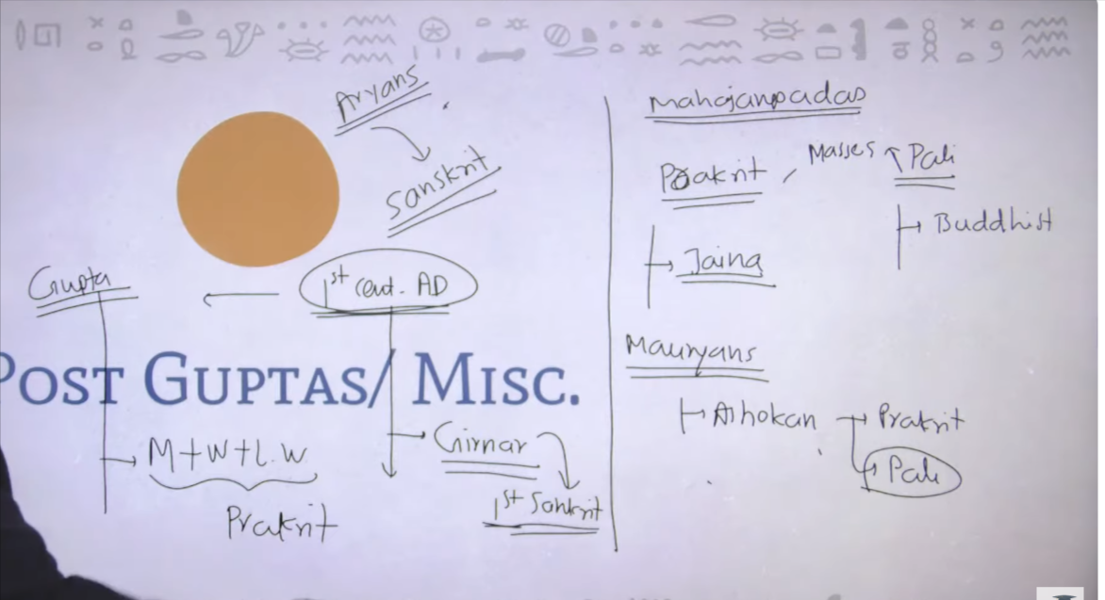

1
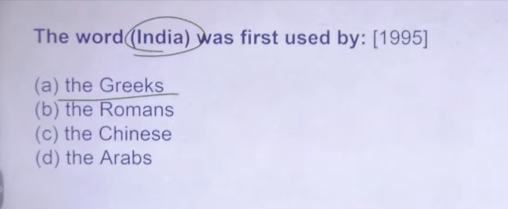
Ans: A

In the Greek literatue we can find this word

2
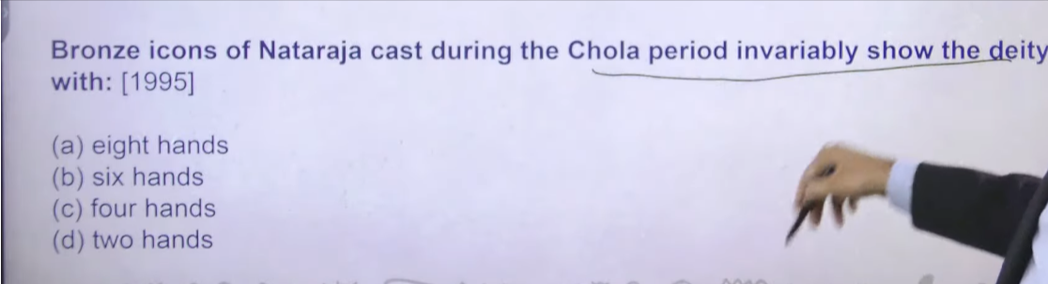
An:C
Chola time per Natraj ke char hath the but later on
Six and egnihg hand bhe ane lage the Natraj ke

3
Badami cave is patronize by chalkuya of Badami
Badami was the capital of western chalykas he was the person who defaeate harshavardhana to he was the king of western chalkyas of Badami

Kahajurao temple chandeal ne banaya tha 11 ce ad ke around
Devgardh – earliest surviving temple ke awvasesh ahi wo devargh temple se mile hai

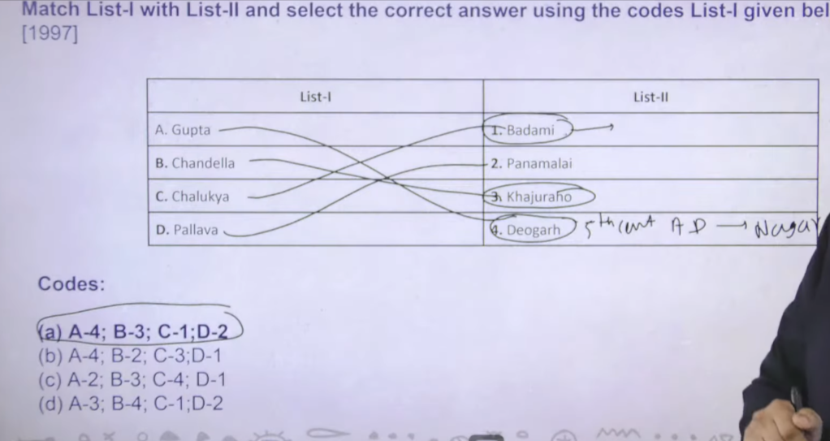

4
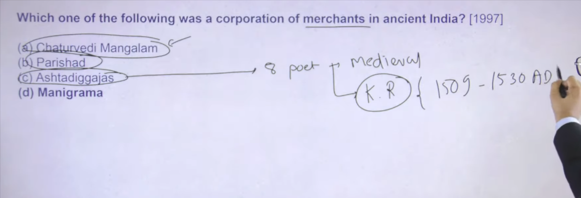

Ans:D
“Corporation of merchants”
👉 व्यापारियों का निगम या👉 व्यापारियों का संघ

- Corporation / Guild = संगठित समूह
- Merchants = व्यापारी
👉 मतलब: व्यापारियों का संगठित समूह जो मिलकर व्यापार करते थे

📌 What is “Manigramam”?
👉 Manigramam was a merchant guild (corporation of traders) in South India

🏛️ Time Period
- Mainly during the Chola Dynasty
- Around 9th to 13th century CE

📍 Key Features
- Organization of powerful merchants
- Engaged in internal and overseas trade
- Played an important role in South Indian commerce
- Mentioned in inscriptions (especially Tamil region)

🌍 Importance
- Promoted long-distance and maritime trade
- Connected India with Southeast Asia

🧠 One-line for UPSC
👉 Manigramam was an important merchant guild of South India during the Chola period.

If you want, I can also explain Manigramam vs Ayyavole vs Anjuvannam in a simple table
Manigramam was a prominent and influential merchant guild (corporation of traders) in medieval South India, operating extensively from the 6th to 13th centuries CE, particularly during the Pallava and Chola periods. These itinerant traders managed both inland and overseas trade networks, dealing in textiles, spices, and precious materials, often collaborating with other guilds like Anjuvannam and the Ainurruvar.
Key details about the Manigramam merchant guild:
- Role & Activities: Manigramam was a guild that organized caravans, ensured the safety of goods, and controlled trade in both port-towns and hinterland trade centers.
- Origin & Spread: Originating in the 9th century on the Kerala coast, it later became highly influential throughout Tamil Nadu and expanded into Southeast Asia.
- Structure & Hierarchy: While an independent association, Manigramam operated within the broader, overarching network of the Ainurruvar (or Ayyavole-500) from the 12th century onwards.
- Influence: Members of this guild held significant social and political sway, investing heavily in temples and acting as elite merchants involved in both local and international commerce.
- Collaboration: Often collaborated with the Anjuvannam guild (a body of coastal/foreign merchants) to manage trading activities, according to Brainly.in.

📌 Guild vs Manigramam (आसान समझ)
🏛️ 1. Guild (सामान्य शब्द)
👉 Guild (संघ/श्रेणी) एक सामान्य term है
- व्यापारी या कारीगरों का संगठन
- अपने व्यापार/काम को regulate (नियमित) करते थे
- ज़्यादातर local (स्थानीय स्तर) पर काम करते थे

🌟 2. Manigramam (विशेष guild)
👉 Manigramam एक specific और प्रसिद्ध व्यापारी संघ था
- दक्षिण भारत में सक्रिय
- समय: Chola Dynasty (9वीं–13वीं सदी)
- बहुत शक्तिशाली और प्रभावशाली merchant guild

🔑 मुख्य अंतर (Key Differences)
1️⃣ Definition (परिभाषा)
- Guild = सामान्य शब्द (कोई भी व्यापारी/कारीगर संघ)
- Manigramam = एक खास, प्रसिद्ध व्यापारी संघ

2️⃣ Scope (कार्य क्षेत्र)
- Guild → स्थानीय व्यापार तक सीमित
- Manigramam →
  - Inland (आंतरिक)
  - Coastal (तटीय)
  - International trade 🌍

3️⃣ Geographical Reach
- Guild → एक शहर या क्षेत्र तक
- Manigramam →
  - पूरे South India
  - Southeast Asia और China तक connection

4️⃣ Nature (प्रकृति)
- Guild → स्थायी (एक जगह रहते थे)
- Manigramam →
  - Traveling merchants (घूमकर व्यापार)
  - बड़े स्तर का व्यापार

5️⃣ Relationship
👉 Manigramam = एक प्रकार का Guild
👉 बाद में यह बड़े संगठन
Ayyavole (Ainurruvar) के साथ जुड़ा

🧠 One-line (UPSC)
👉 Guild एक सामान्य व्यापारी संघ है, जबकि Manigramam दक्षिण भारत का एक शक्तिशाली और अंतरराष्ट्रीय व्यापार करने वाला विशेष merchant guild था।

Manigramam refers to a prominent medieval merchant guild that operated primarily during the Chola and Pallava periods in South India.
The term guild (known in ancient India as Sreni or Nigama) does not belong to just one single dynasty, but is a prominent feature of economic organization across several periods in ancient and early medieval Indian history.
Based on historical records, the guild system (Sreni) was most notably developed and prevalent during the following eras:
- Mauryan Dynasty (c. 322–185 BCE): Guilds became formal institutions,, regulated by the state, as discussed in Kautilya's Arthashastra.
- Post-Mauryan Period (c. 200 BCE – 300 CE): Flourished under the Sungas, Satavahanas, and Kushans, with guilds acting as banks and receiving donations, as evidenced by inscriptions at Sanchi and Bharhut.
- Gupta Dynasty (c. 320–550 CE): Guilds reached their zenith (highest point), enjoying significant autonomy, issuing their own coins, and managing their own laws.
- Chola Dynasty (9th–13th Century CE): Powerful merchant guilds like Ayyavole-500 and Manigramam were crucial for maritime and inland trade.
Key Aspects of the Guild (Sreni) System:
- Function: They were associations of artisans, traders, and bankers that regulated production, quality, prices, and wages.
- Autonomy: They had their own laws, insignia, and flags, particularly during the Gupta and Chola periods.
- Banking: They operated as bankers, receiving deposits and issuing loans.
The term Sreni is found as early as the Vedic period (meaning a line or group), but the organized functional guilds appeared in the subsequent dynasties mentioned above.

Chaturvedi magngam – means char vedo ko ratne wala insaan Chaturvedi magnaalam it was not the bocos of the merchants it is the related with priest corporation of priest
There were theim time who has the class which have the total nknowled of all four vedas in north india certain people today uses as sir name

Parishad = later vedic age me hum lgooko ek priestly body ka example milta hai pahle parishad ek priestly body the but later on Mauryan period me ye ek mantri parishad bani council of mistier to ajj bhe chalta hai

Asthadekgajas= 8 poest the mideval india me jinko patronize karne ka kaam raja krishnadev rayay ne rough time is 1509=1530ad

Unke paas asthadegajas the he was the king of vijaynagar dyanste
Unke pas asthadegajas the

Ashtapradahan ek aur word hai is the council fo misnter of shivajimahraj

Manigram – ya nagaram = village merchant ke jo body the it was not settle in ancient tiem ye log ek jagah se durser jagha gumte the but later on they got settle down in town life style usek baad hum lgono ne bade bade nagras ke naam sune Mauryan time onward
Nagar is the large city habituated by big merchangt body so it was somehere associated with merchant body

5
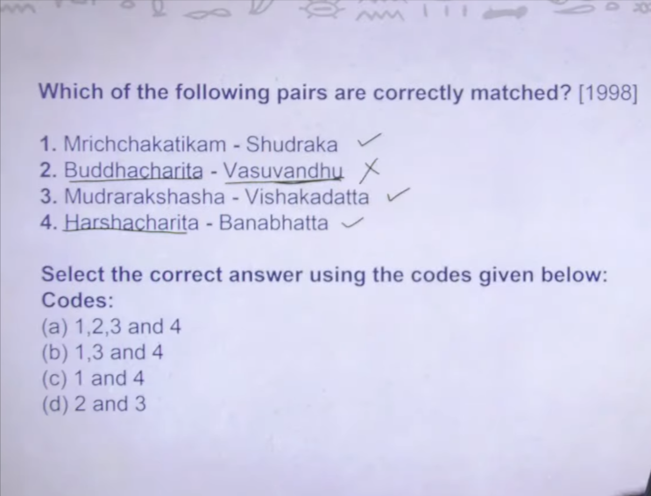

Ans:B

Harashachartia bananbhatta ne likha tha
Banabhatta ke do book hai harshachartia and Kadambari ye dono book banabhata ne likhe the harshadchit is the biogroy of Harshavardhan banabhatta is the court poest of harsha

Buddhachartia=- ashwagohoasha ne likha tha
Ashwagoasha as well as vasumitra these two are queit big buddhist person during the time of kansihka
Vashumitra and vashuvandhu both are sme person he was the time of foruth buddhist council of kinisha he was the chariperosn of foruth buddhsit council vashumitra mitran menas vandhu

6
Megaasthaneej was the first traveller he came during the court of chadragutpa Maurya 323bc- 297bc during this time he came
Celucs nicater jb haar gayay the chandrutpa muayran ke against to neckater ne apna ek ambessodor bheja tha Mauryan ke court me that woas megasthaneej
After that
During the time fo chandrugutpa second 5 ce faihen came
Faiehen came india to visti the placed related to buddha so he came india as such faishen ne changutpa second and surrounding people ke bare me nahilikh kar Rakha ah but when he talk about wherne he used to talk about regional places use hum lgoo ko conetempaory period ke ke jankari milte hai

Heiunsang – he came during the time of harshawvahdna he was the last greatset ruler of hindusm whener he was not hindu he was buddhist person fir bhe inko rast hindu greaer ruler bote hai
Heiunsandg came in order to to study in Nalanda inko naladna me padhna tha isley india ayay
But once he was in india he tour acroos india he went and meet south kindom also north me peshawr purshupura tke ke information apne text me likh kr rakhe hai

Then after itsing came he also vistion inia to visti the place relted to buddhistm he visiton 7 the ce ad ke round
One is the ambessoder remaingi are chieset traveller

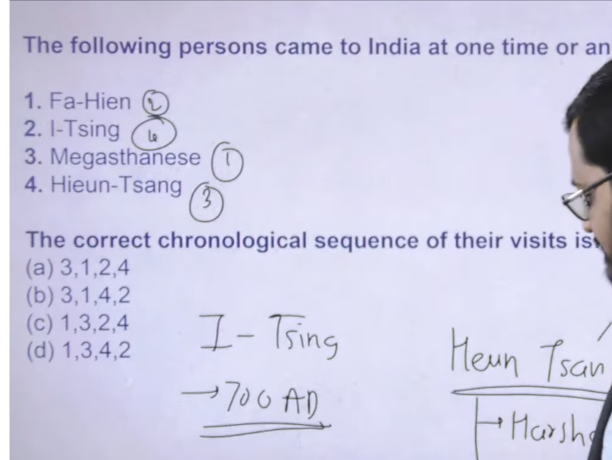
Fa-Hein-5th 399-414 CE
Megasthenes- 4th BCE 302BCE
Hiuen-Tsang-7th CE 629-645CE
I-tsing =7th 671-695

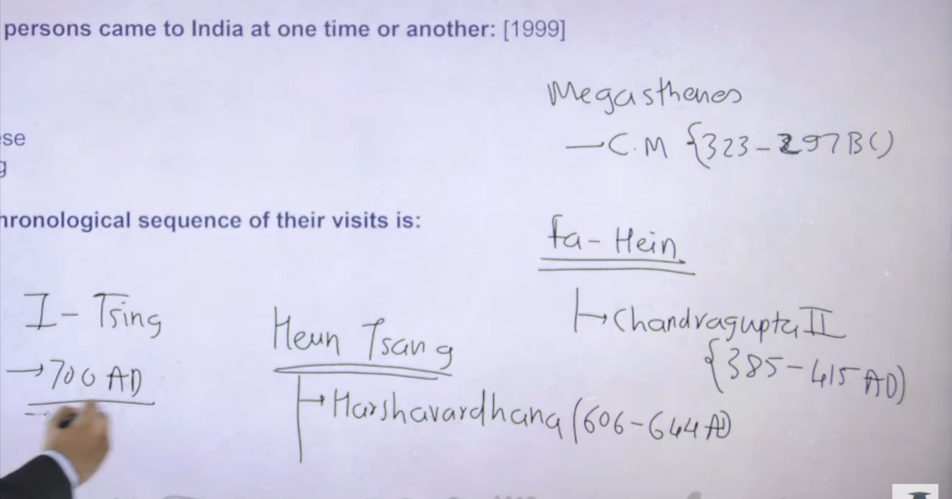

Fa-Hien (Faxian), a Chinese Buddhist monk, visited India in the early 5th century CE. He traveled to India between roughly 399 CE and 414 CE during the reign of the Gupta Emperor Chandragupta II (reigned c. 380–415 CE) to obtain authentic Buddhist scriptures.
www.livehistoryindia.com +3
- Arrival Period: Early 5th century (approx. 400–410 CE).
- Reign: Chandragupta II (Vikramaditya) of the Gupta Empire.
- Purpose: To find and study Buddhist texts/monastic rules (Vinaya Pitaka).
- Key Locations: Visited Pataliputra, Mathura, Kanoji, and Bodh Gaya.
- Documentation: Recorded his journey in his travelogue, A Record of Buddhist Kingdoms (Foguoji).

Megasthenes, a Greek ambassador and historian, visited India in the 4th century B.C., specifically arriving around 302 B.C.. He was sent by Seleucus I Nicator to the court of Chandragupta Maurya in Pataliputra, where he documented his observations in the now-lost work Indica.
Prepp +2
Key Details About Megasthenes' Visit:
- Century: 4th Century B.C. (roughly 302 B.C.).
- Reign: He visited during the reign of the Mauryan emperor Chandragupta Maurya.
- Origin: He was a Greek ambassador/diplomat sent by Seleucus I Nicator.
- Work: He wrote Indica, which provides valuable, albeit sometimes inaccurate, information about the geography, society, and culture of ancient India.
- Significance: Known as one of the earliest foreign observers to provide a detailed account of India.

Hiuen Tsang (Xuanzang), the famous Chinese Buddhist monk and traveler, visited India in the 7th century, specifically between 629 and 645 CE. He traveled during the reign of Emperor Harshavardhana to study Buddhism, visit holy sites, and obtain original Sanskrit scriptures, documenting his journey in the "Si-Yu-Ki".
Testbook +4
Key details of his visit:
- Period: 7th Century (approx. 629–645 CE).
- Ruler: He arrived during the reign of Harshavardhana (c. 606–647 CE).
- Location: He spent significant time studying at Nalanda University in Bihar.
- Purpose: To collect Buddhist scriptures and study in India.
Testbook +4
His detailed accounts provided valuable information about 7th-century Indian social, political, and cultural lif

I-tsing (Yijing), a Chinese Buddhist monk and traveller, visited India in the 7th century, specifically between roughly 671 and 695 CE. He arrived by sea, traveling to study and translate Buddhist texts, and spent over ten years studying at the renowned Nalanda University.
Testbook +3
Key details about his visit:
- Time Period: 7th Century CE (671-695 AD).
- Route: He arrived by sea from Canton (Guangzhou).
- Purpose: To study Buddhism and collect Sanskrit texts.
- Significant Studies: Spent over 10 years at Nalanda.
- Records: He wrote A Record of Buddhist Practices Sent Home from the Southern Sea, providing detailed insights into Buddhist monastic life

7
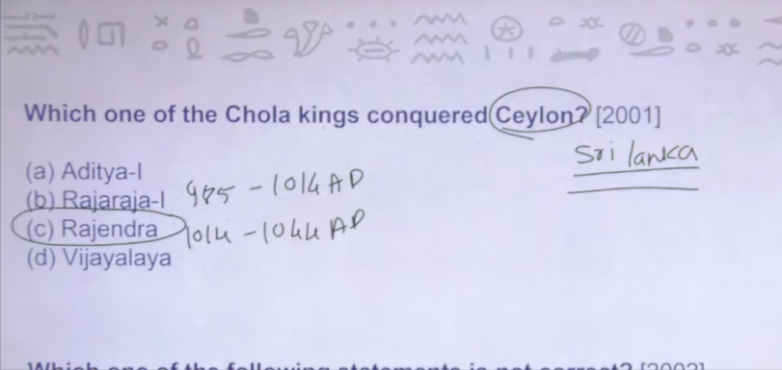

Ans: C

Celon is the ancient name of srilanka celon capture karne ka kaam kyia tha pita putra ke jodi ne kyia tha sabse pahel fater rajraja fist pees peniselvin bhe bola jata hai jinke uppar movie bhe bane the then after his son and succession Rajendra first ye dono ne milkar celon capture kyai tha father ne adha celon capture kyia tha and beta ne puraka pura celon capture kr lyia tha

Rhen answer will bhe Rajendra chola

8
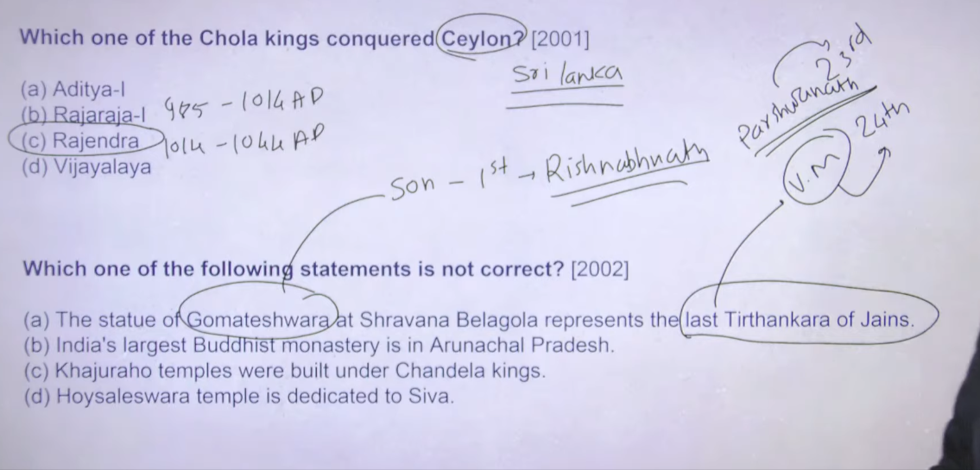

Ans:A

Parshavant given the frist foru principal of anuvrata and vardhaman mahvir added one more anuvrata that is brahmachayra
Gometeswara ka state hai Shravan belgola me kafte huge statue hai

Majority of south india temple dedicated to shiva onely h
Holyaslwara temple hoysaley dynasty ne banya tha dwarsamduram ke around inke capital the halebude and dwarasamdura modern day Karnataka

Waise he rajaraj 1 ne bradhewara temple banya tha tanjaur me
Tanjaur me he gangaekonda chlapuram temple hai jiskeo banya tha Rajendra chola ne ye dono temple bhe shiva keo dedicated hai most of the south india ke bade temple shiva ko dedicated hai

9
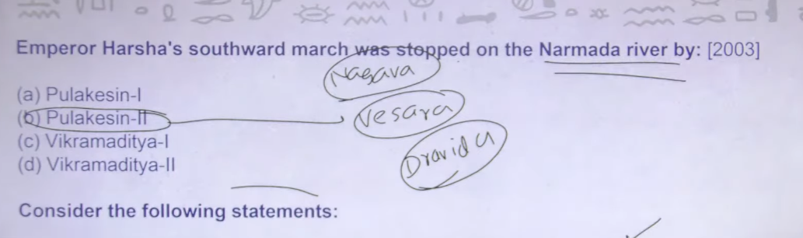

Chalkuas of Badami ka greatest king tha pulakesain second
Aur pulakesing second and harshvardha ke beech me narmada per ek war fare hua tha pulakeshin second defeated Harshavardhan
Isne he baad me Badami cave and ehole ke temple banyae the
This fellow is also credit vesara school of architeure
North me njo nagra and sourht me dravina architer ka style chalte hai uska amalagametion apko imlega vesara me
To ye pulakeshin second ke time se chalue hue vesara
To ehole jo inke andar ek city the ehole is also called as crealdddle of Indian architer temple architer
Creaddel me jhlua jhle me hse he sabe bache bade hote tha to creaddel fo Indian temple architer is ehole

Harssha uniterdd north india he also lost only one battle agains badmi chlakuy
Pulakaesh also patronize Badami cave nscriopin inscritopin

10 Both are correct

South inda eleventh and tenth c eke ardoun south ke chola ke under me tha chola ne chapteur karke Rakha tha
Pandya jo madurae tamilanaidu wale area me rule krte the chera jo ke kerla wale area me rule krte the chola ne in dono ke defeat ekyia tha
Chola ne ek baar south india capture kr lyei fir unheon south east trade route itna important tha
Then they go to the expeditation against suth eastern dynasty sailendra empire java as well as Malayan penninusla wala area ahi wo capture karne ka kaam chola ne kyia tha

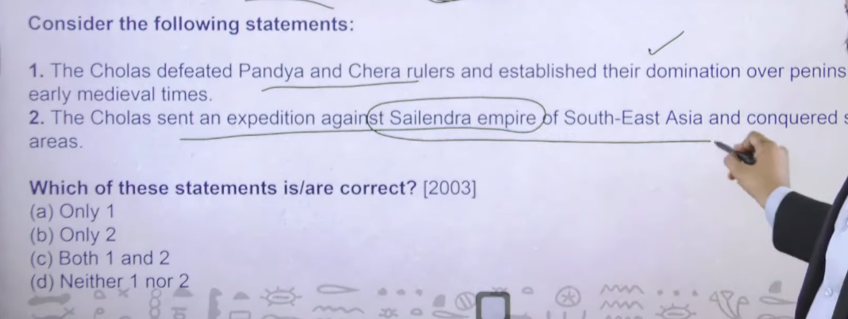
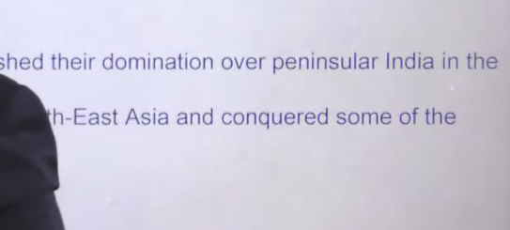

चोलों ने दक्षिण-पूर्व एशिया के शैलेन्द्र साम्राज्य के विरुद्ध एक अभियान भेजा और उसके कुछ क्षेत्रों पर विजय प्राप्त की।
expedition means
📌 Meaning of “Expedition”
👉 Expedition means:
a planned journey or mission for a specific purpose

🪖 In History (UPSC context)
👉 It usually means a military campaign (सैन्य अभियान)

📖 Hindi Meaning
👉 अभियान
👉 सैन्य अभियान (in war context)

🧠 Example
👉 Cholas sent an expedition
= चोलों ने एक सैन्य अभियान भेजा

⚡ One-line
👉 Expedition = a planned journey, especially a military campaign
📌 Meaning of “Military Campaign”
👉 Military campaign means:
a series of planned military operations (battles/fights) carried out by an army to achieve a goal

📖 Hindi Meaning
👉 सैन्य अभियान

🧠 Easy Explanation
👉 जब कोई राजा या सेना
- किसी क्षेत्र पर कब्ज़ा करने
- दुश्मन को हराने
के लिए लगातार युद्ध (series of battles) करती है
➡️ उसे military campaign कहते हैं

🪖 Example
👉 Cholas sent a military campaign to Southeast Asia
= चोलों ने दक्षिण-पूर्व एशिया में सैन्य अभियान चलाया

⚡ One-line
👉 Military campaign = planned series of battles by an army

11 Answer is none of the above D

Faihen india kb aya to somhewer around 385ad 415 ad ke beech me
Foruth buddhist council fo kanisha happen in between the period of 1 se lekar 2nd ce ad iska exact time period abhe tohad sa debatable hai
In dono ke beech 200 saal ka difference hai to fiahen fruth buddhst council ke time per nahi tha first is wrong

Harsha himself is the follower of buddhism to how can it possible that he is antagonistic toward the buddha to ye wala bhe statement gala tahi

Harshawardhan was the patronizer and great propounder of the buddhsim we can say that
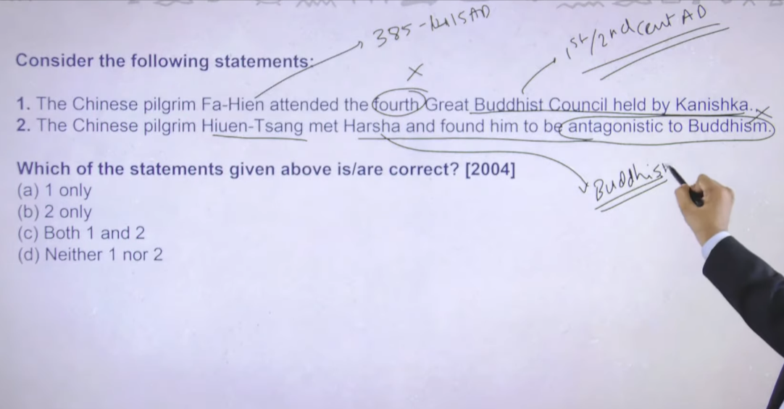

👉 Pilgrim means:
a person who travels to a holy or religious place

📖 Hindi Meaning
👉 तीर्थयात्री

⚡ One-line
👉 Pilgrim = a person going on a religious journey
antagonsitic to buddhism means
📌 Meaning of “Antagonistic to Buddhism”
👉 Antagonistic means opposed / against

🧠 Full Meaning
👉 “Antagonistic to Buddhism” means:
being against or opposing Buddhism and its teachings

📖 Hindi Meaning
👉 बौद्ध धर्म के विरोध में

⚡ One-line
👉 Antagonistic to Buddhism = opposed to Buddhism

12
First is wrong because ishvaku jo hai during the time of gupta empire gutpa ke teriotry kabe bhe panindia nahi the inka jo majority of influence tha wo madhyapradesh se bihar tk tha maxiumen teriotial influence tha iske alwa inhone Gujrat andmahrajstra wala area capture karke Rakha tha but feudatireis ke trhough matlab wo area king ko harakar feudatories inhone baitha dyia the jb ye log north me rule kr rahe the tb south me odhissa ke around ishvaku rulers the to ishvaku ne ihindusam as well as buddhism dono ko patronize karne ka kam kyia hai

Pala ruler founded by Gopala somheware around 750 AD thereafter ye jo dynasty hai collapse hue somehwerhe around 1209 ad ke around
Baktiyar Khilji ne Bengal ke uppar attack kyia tha aur pala dynsty ka jo last rulder tha lakshmansena defeated and kill
Bakyitayr khili also destroyed Nalanda university to naladna universt agar 12 th cenruy tk survive the to pala ruler ne unko patronization dyia hoga
Nalagnd university jo hai wo buddhist university hai
Ans:B

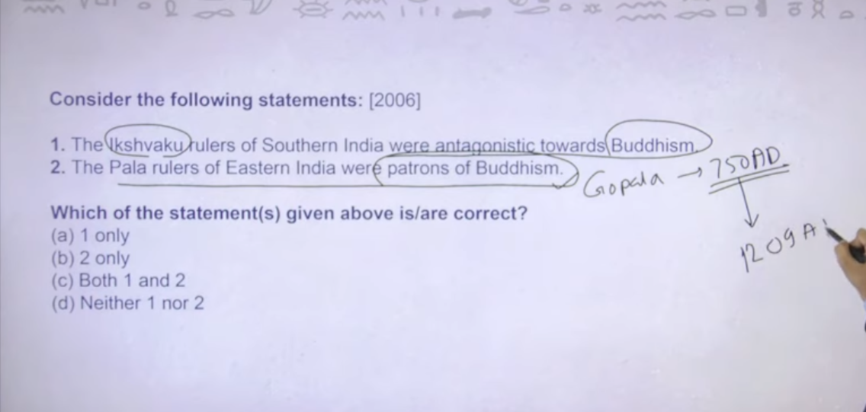

13 ANS:b

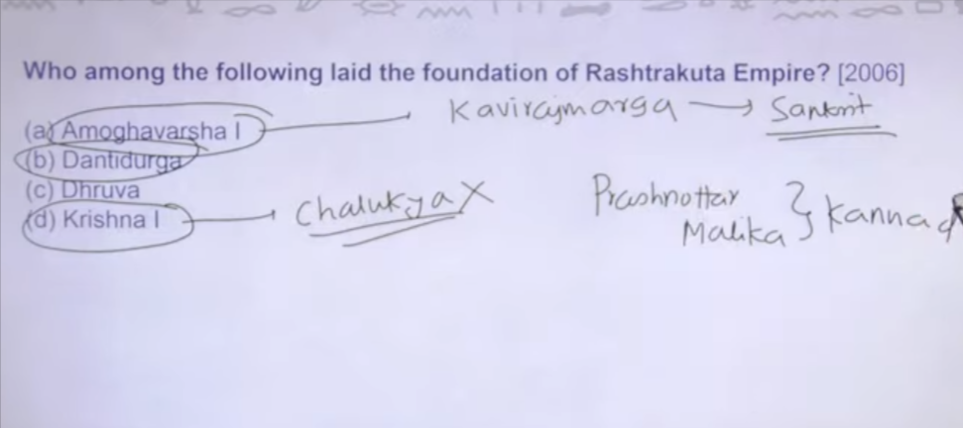

Rastrkuta ka jo founder tha wo tha dantidurga he was the founder of rastrkuta dynasty

Inke jo anya ruler the like krishna first ne Badami ke cahlkuya ko harane ka kaam kyi a tha then after
Amogwarsha first is also quiest famous for his two book kavrirajmarga , prashnotar malik
Pranhotarmalik book is consider as first book on kannada poetry
Kavriajmargah is sanskrt book

To jo kannad ka earliest remanant text hai wo amoghvarsh se usalley trace kyia jata hai
Rastrkuta south india ke kafi bade dynasty hai

14 Ans: D

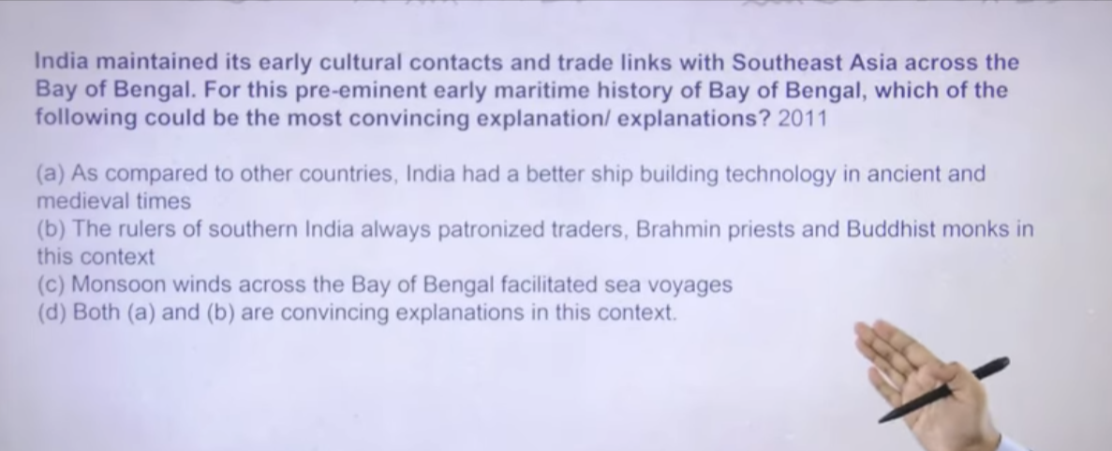

Inka yahe puchan hai ke early Indian history me jo bay of Bengal se trade flow ho rahe the uska sabse important reason kya hai

India me shru se at the timeof haddpan ship building industry k evidence mile hai

To our ship buling industry was quiet good during ancient time chola dynasty ne south east asia bhe capture karke Rakha tha kuki navy inke kafe ache the
So first is correct

Second is also correct trade me wahe rahega jinke paas Jayda paisa hai us samya society me sirf do clas ske paas Jayda paisa tha ek to ruling class aur dusre priestly class
Gutpa time per aur late ancient india me humne dekha hai ke jo buddhist monestary the Jaina ke pagudas the brahmans ke temple inke wale areas bade bade trading town hua karte the to agar inko patronization mil rahahhai to inke jeeb bhar rahe aur ye wala paise ye kaha utilize kr rahe hai to trading me

C is wrong because monsson wind jo hai wo arbian sea voygaes facitlitaes Samudra safar hai ukso facilitate krta tha to uska jyada asar arbian sea per nak e bay of Bengal per nah tha

15 Ans: C

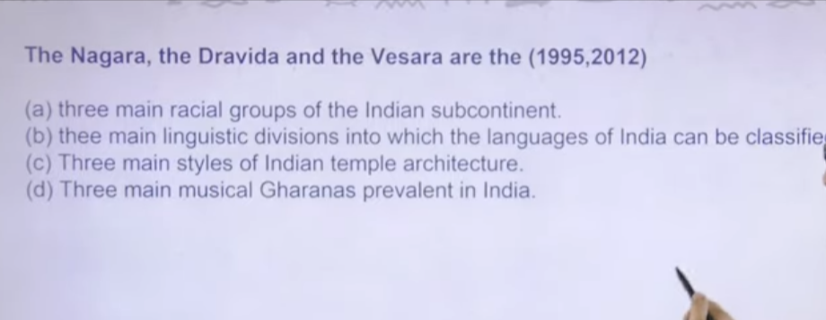

16 Ans: B So 2 and 3 will bhe the ultimate answer here

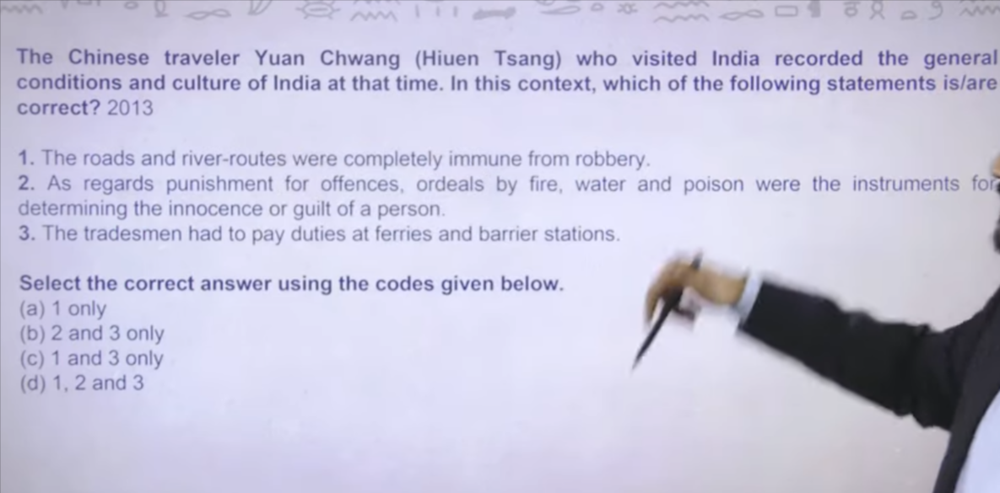

👉 “Immune from robbery” डकैती / लूट से सुरक्षित या लूटपाट से मुक्त
👉 Immune from robbery = लूट से सुरक्षित

अपराधों के दंड के संबंध में, आग, पानी और विष द्वारा परीक्षा (ordeal) किसी व्यक्ति की निर्दोषता या दोष सिद्ध करने के साधन थे।
👉 दंड के लिए आग, पानी और विष से परीक्षा ली जाती थी, जिससे दोष या निर्दोषता तय होती थी।

“As regards punishment for offences, ordeals by fire, water and poisonwere the instruments for determining the innocence or guilt of a person.”
- As regards → के संबंध में
- punishment → दंड
- offences → अपराध
- ordeals → परीक्षा / कठिन परीक्षण
- by fire → आग द्वारा
- water → पानी
- poison → विष
- instruments → साधन
- determining → तय करना / निर्धारण करना
- innocence → निर्दोषता
- guilt → दोष / अपराधी होना
- person → व्यक्ति

👉 अपराधों के दंड के लिए, आग, पानी और विष से परीक्षा लेकर यह तय किया जाता था कि व्यक्ति दोषी है या नहीं।

“The tradesman had to pay duties at ferries and barrier stations.”

- The tradesman → व्यापारी
- had to pay → भुगतान करना पड़ता था
- duties → कर / शुल्क (tax)
- at ferries → घाटों पर (नदी पार करने के स्थान)
- barrier stations → चौकी / नाका (check posts)

👉 व्यापारी को घाटों और चौकियों पर कर देना पड़ता था।
👉 Tradesman paid tax at ferries and checkpoints

First is wrong heiunsang ne apne book me likh kar Rakha hai ke more than three occasion he himself was ro ek occasion me usne batya tha uske kapde silk ke the to rober ne uske kapade bhe utra lyia the per near by village me uske jakar kapde magne pade
Ek occaosin me batya ki roboer ko dene k lyie uske pass kuch nahi tah to rober ne uske jalte aga me chod dyia phir mai bacha because iahve dirct cotanct with budhism
Ye tohde flattery the thoda khud ka prasie tha to ultimately roober to ho rahe the ye to pata chala tha roads are not safe
To agar itna bada admi huensandg himself rob ho rah haito ordingary janta ka to ap soch skate ho

2
Agg se guruo agar baach gae to bhawgawn ke dyaa se app innocent prove ho jayenge apke samen do payle rakhe jaenge ek mepoins eand ek me water hoga udhakar pee lo agar aapp bach gae to agar ap bach gae to u are not guilty agar app mar gae to u are guilty thod sa Bhagwan se related cheze Jayda chalte the to ye ordeal by fire and pioins ye common cheze the aancient time me guilt prove karne k lyie use kyai jaydyt tha koi material evidence nahi mange jate the
App karo ye cheeze agar ye cheez karke app surive hog ae to obviously u are not guilty agar app mar gae to u are guilty to ye sare cheze bhe heiunsang ne likh karr rakhe hai

  - is correct heiunsang ne batya ke river trade sea trade and land routhe trade bhe hota tha har entry and exit point per apko tax pay karna padta tha
ot answer is 2 and 3

17

Mural painting is the only painting that directly painted on rock or wall to koi bhe directly wall per paitingt modern indiame apne dekha hoga grafity dekhte hia grafity is the type fo mural painting ancient india me jo mural painting hai wo fresco technology se jane jate the to ye fresco technology wala hum logo ko kaha kaha per instance mila hai

Sanci sutpa to bilkul bhe nahi kuki ye Ashoka ke time per tha aur Ashoka ke time per as such koi painting the he nahi paitng nahi ye sculpture per jayad yakeen karete the pathar ko tarash tarashk kare ye murtyia bante the rather than paingt

Ajanta cave and lepakshi temple donome apko wal paing milege
Ans: 1and 2

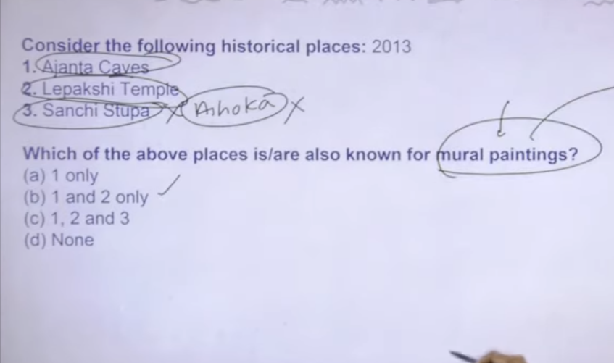

Mural painting is an artwork applied directly to a wall, ceiling, or permanent structure, uniquely characterized by its integration with architecture. Originating in prehistoric caves and historically spanning temples and palaces, murals are often large-scale, durable, and used to convey social, religious, or cultural narratives in public or private spaces.
Key Characteristics of Mural Painting:
- Architectural Integration: The painting is designed to blend with the specific structure, space, and texture of the wall.
- Permanent Substrate: Unlike canvas, murals are inseparable from their background (stone, plaster, concrete).
- Accessibility: They are often found in public spaces, making them accessible art that can act as community landmarks.
- Techniques: Common techniques include fresco (painting on wet lime plaster) and fresco-secco (painting on dry plaster).
History and Significance:
- Ancient Roots: Cave paintings are considered the earliest form, with later examples seen in Egyptian tombs and early Roman architecture.
- Cultural Expression: Famous examples include the Ajanta Cave paintings in India, the murals of the Vatican City by Raphael, and the Mexican Mural Movement.
- Themes: Subjects range from religious mythology and stories of daily life to modern social or political commentary.
Types of Mural Techniques:
- Fresco: Pigments mixed with water applied on thin, wet lime plaster (Fresco-buon).
- Secco: Painting directly onto a dry plastered wall.
- Mosaic: Decorative design created using small pieces of glass, stone, or tile.
- Graffiti: A modern, often spray-painted form of wall art.
Murals are designed to transform, enhancing the atmosphere and aesthetics of both interior and exterior spaces.

18

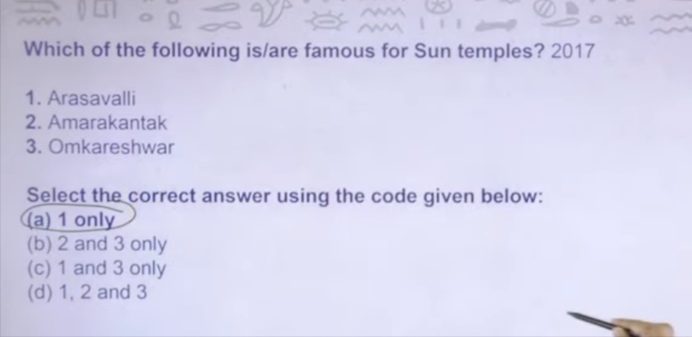

19 ANS: so it is nothing but measure of land A

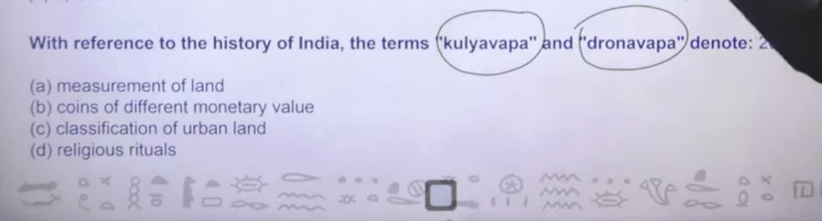

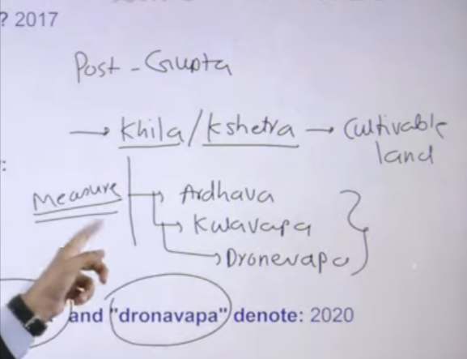

During the time of post gupta period land ko khila khestra bola jata tha ikso cultivable land bolte the and there after land ko measure karne k lyie different unit are theer ardhvapa, kulavyapa, dronvapya ye jo teen hai unit of measurement hai for the for the khila and khestra

20 Ans:C
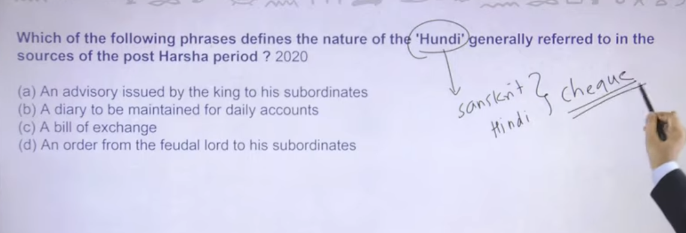

Hundi ajj bhe sanskrti word hai it is nothing but cheque tojo aap bank ka cheque bote hai ukso bote hai hundi
Then agar chezue ko technical word me likhoge to it is nothing it is just bill foexchange
Appke jo currency eke note hote hai wo bhe ek type of bill he hota hai it is the type of bill onely jo app kise ko pay kar sakte ho
To waise he cheque bhe it is type of bill jo app utilize karke payment kr skte ho it is nothing but bill of exchange hundi system ancient india me kafi chalte the

21

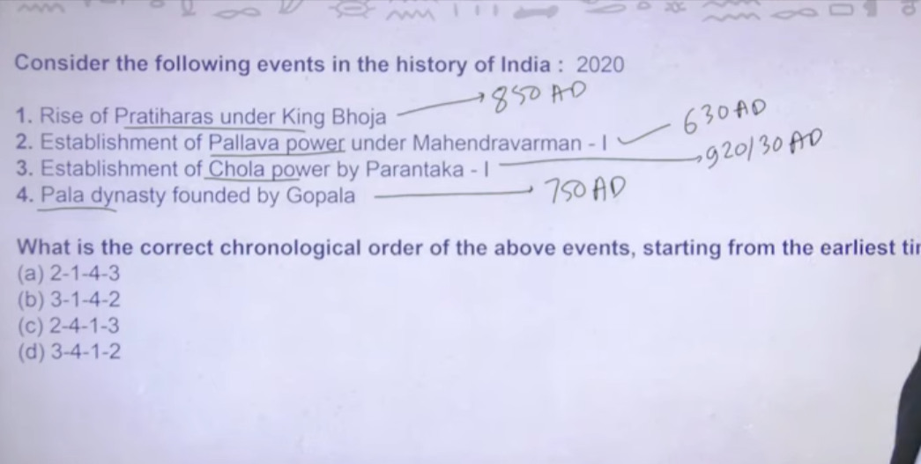
Inka sabse palin thing hai ke sau sau saal me eke ek karke aye the

Pulakesian second is direct war head with harshavardha and southern side me mahendravarman
To somehere 630ad ke around ye log the mahevadrvaman ka he beta ahi narshimaverman mahamallpuram jisme Mahabalipuram city bane the

Boja ne ke city bhe bane the bhojpala jisko app aj Bhopal ke naam se jante ho

Chola ko vijaylay ne form kyia tha but yaha per agar vijyalay ka era dalte hai to kadbad ho jate hai because wo direct coincide hota hai vijayalay ka area prathhara se

22
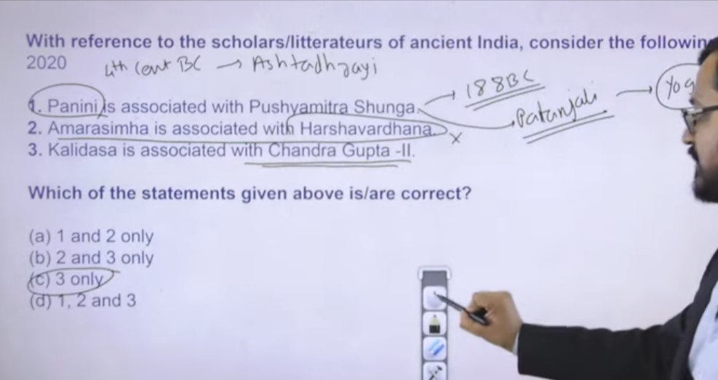

Pani ke asthadyadee me pana aur karhspana ye do naam mention hai ye do coin hai
Pani is 4h centayr bc iska ek book hai ashtadyaii
Pushyamitra shuna is 188bc kill later ruler of Mauryan to ultimately ye dono ek durse ke sath nahi associated hai
Pusyamitra shunga ke sath associated tha Patanjali, yoga
Patanjai he used to be very huge priest during the ancient kingdom he had officiated lots of sacrifices that were carried out by the pushyamitra shunga
Inko he pura ka purja sherya jata hai for veda shool of vedang Indian school of philosophy inhone he banya tha

Thenafter
Amarshima ke lexicon hai dictionary hai which was created during the gupta empire harshwavardhan to kaf badd me aye to ye wrong hai

ANS: 3 third one abasolutiely write

23

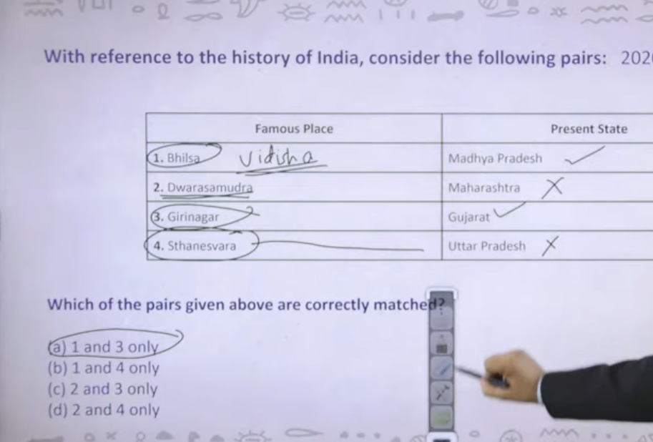

Bhilas is modern day Vidisha – mp
Dwarasamdura , and there after halebedu ye capital th hoyesaala ke to agar app hoyesaala temple search karete to apta chalta dwarasamudra Karnatak me ata hia

Girniar inscription jiske uppar first Sanskrit inscription hia – gujrata
Thareswar earliest captioal hote the harshvardahn ke dyanty ke
Hashvardhan father and brother ruled from thaneswahr
Andtherafter harsvardhan ne thaneswar se captioal change karke kar lyia tha kananuj

Thaneswar kurushetra ke around ata hia modern day Haryana

Ans: 1
24

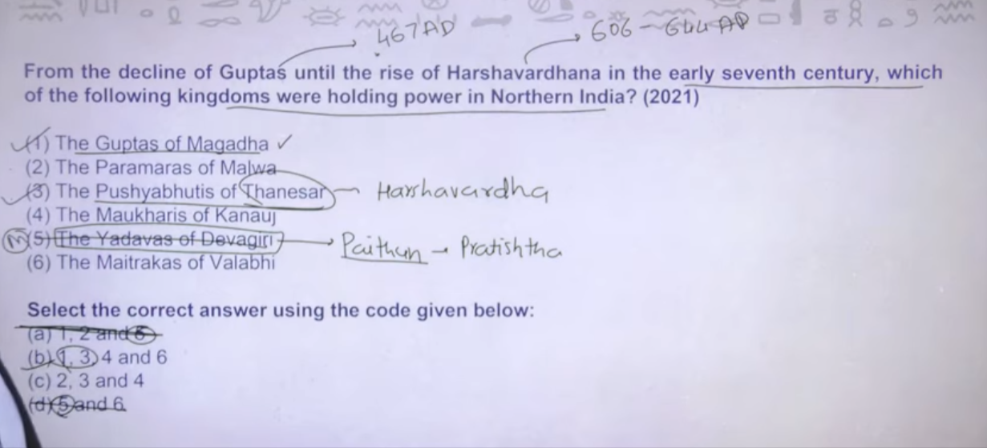

To gugpta ka last greatedst king hia uska naam hai skandgutpa he died in 467 AD
Bale he skandgupta mar gayay but gutpa ka decline hone me time laga tha ine later gutpa ke later king rule kar rahe the wo utne strong nahi the but the

Pushyabhut of thaneswr = harswarrdahn ke dynasty ka he naam hai uharsha ka capital bhe thaneswar tha to harsha ka dynasty bhe ikse beech me rahega uske pahle uske brother and father are rruler

Devgiri modern dya paithan me hai paithan jisko prathesthan bhe bote the modern dya mahrastra me hai ye medival time me Yadava ruler ke paas me tha ye Yadava ruler ko harane ka kaam kyia tha that was malik kafoor jo me ajo allauding khillji ke time per tha to ye medival india ke dynsty hai ancient india ke difentily naih ia

ANS:B

25

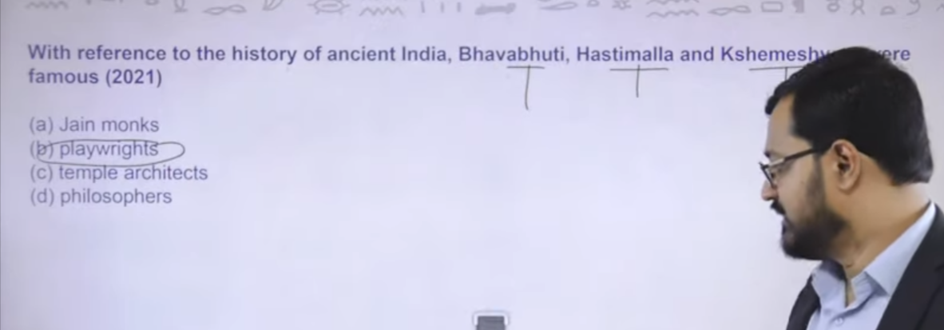
Bhavbhut, hastmall , kameswar they are playwrter apne ane time ke ye deecaan plateau ke playwriter hai different different regional dynasty ke lyie inhone kaam kyia hai

